ilume 44, Issue 1

|  |  |  |  |  |  |  |
| --- | --- | --- | --- | --- | --- | --- |
| 1 |  | £ | t! | UI  1  I HIIUH  ■■9 | 1  m  5 L |  |
| me latest technology makes access control easier than evei | | | | | | |

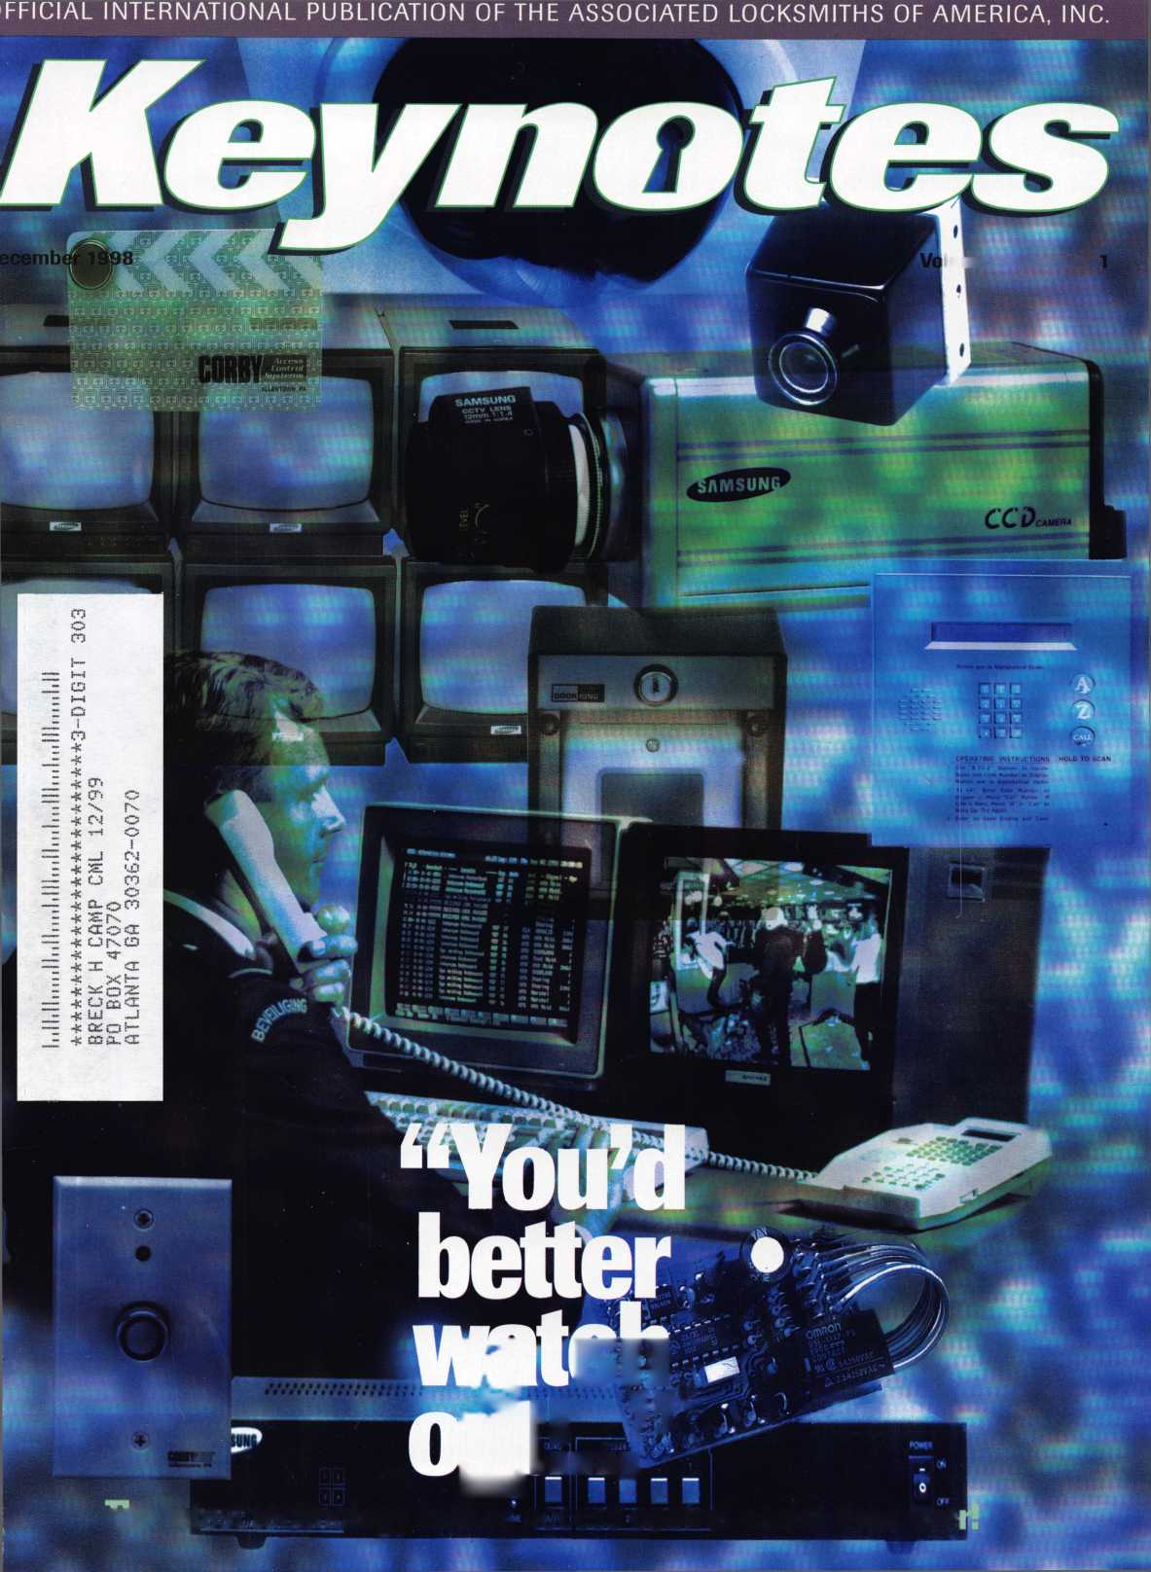

Feel

Luckv?

f

You wouldn’t dream of leaving your success  
to chance. You know that making it in the safe  
and vault industry requires hard work, continual  
improvement of techniques, and constant research  
of the latest products and tools.

Your best bet to excel in all these areas is  
SAFETECH ’99 where you can save your luck for  
the casinos, and get down to business viewing  
the latest products, talking with the manufacturers,  
and training in the latest methods of

safe and vault technology.

Make your plans now to attend  
SAFETECH ’99 May 3-8, 1999  
in Las Vegas, NV.

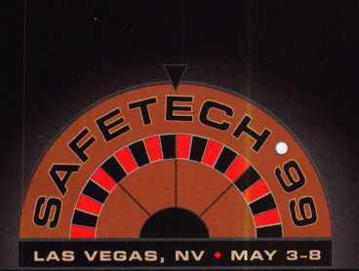

Contact:

Safe and Vault Technician) Association

3003 Live Oak Street  
Dallas, TX 75204  
214.827.7233  
214.827.1810 fax  
email: [convtion@anet-dfw.com](mailto:convtion@anet-dfw.com)



***Reader Service* *#1***

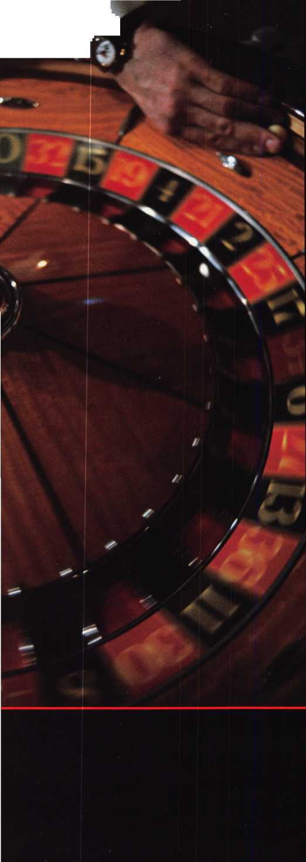

**You could win this** ITL 950- **worth** $2,250!

**jw early. Don’t lay an**

gets tjie ITL950

Wise ALOA members who pay their dues before January 1,1999  
will receive even more than another year’s valuable membership  
in their professional association. They’ll be included in a drawing  
to win this revolutionary code machine donated by Intralock Tools Ltd.  
the ITL950-a $2,250 value!

For more information about the ITL950 contact Intrali by phone at 888.264.6627, or write to 2639 Progressix Unit B, Abbotsford, BC, Canada, V2T 6H8.

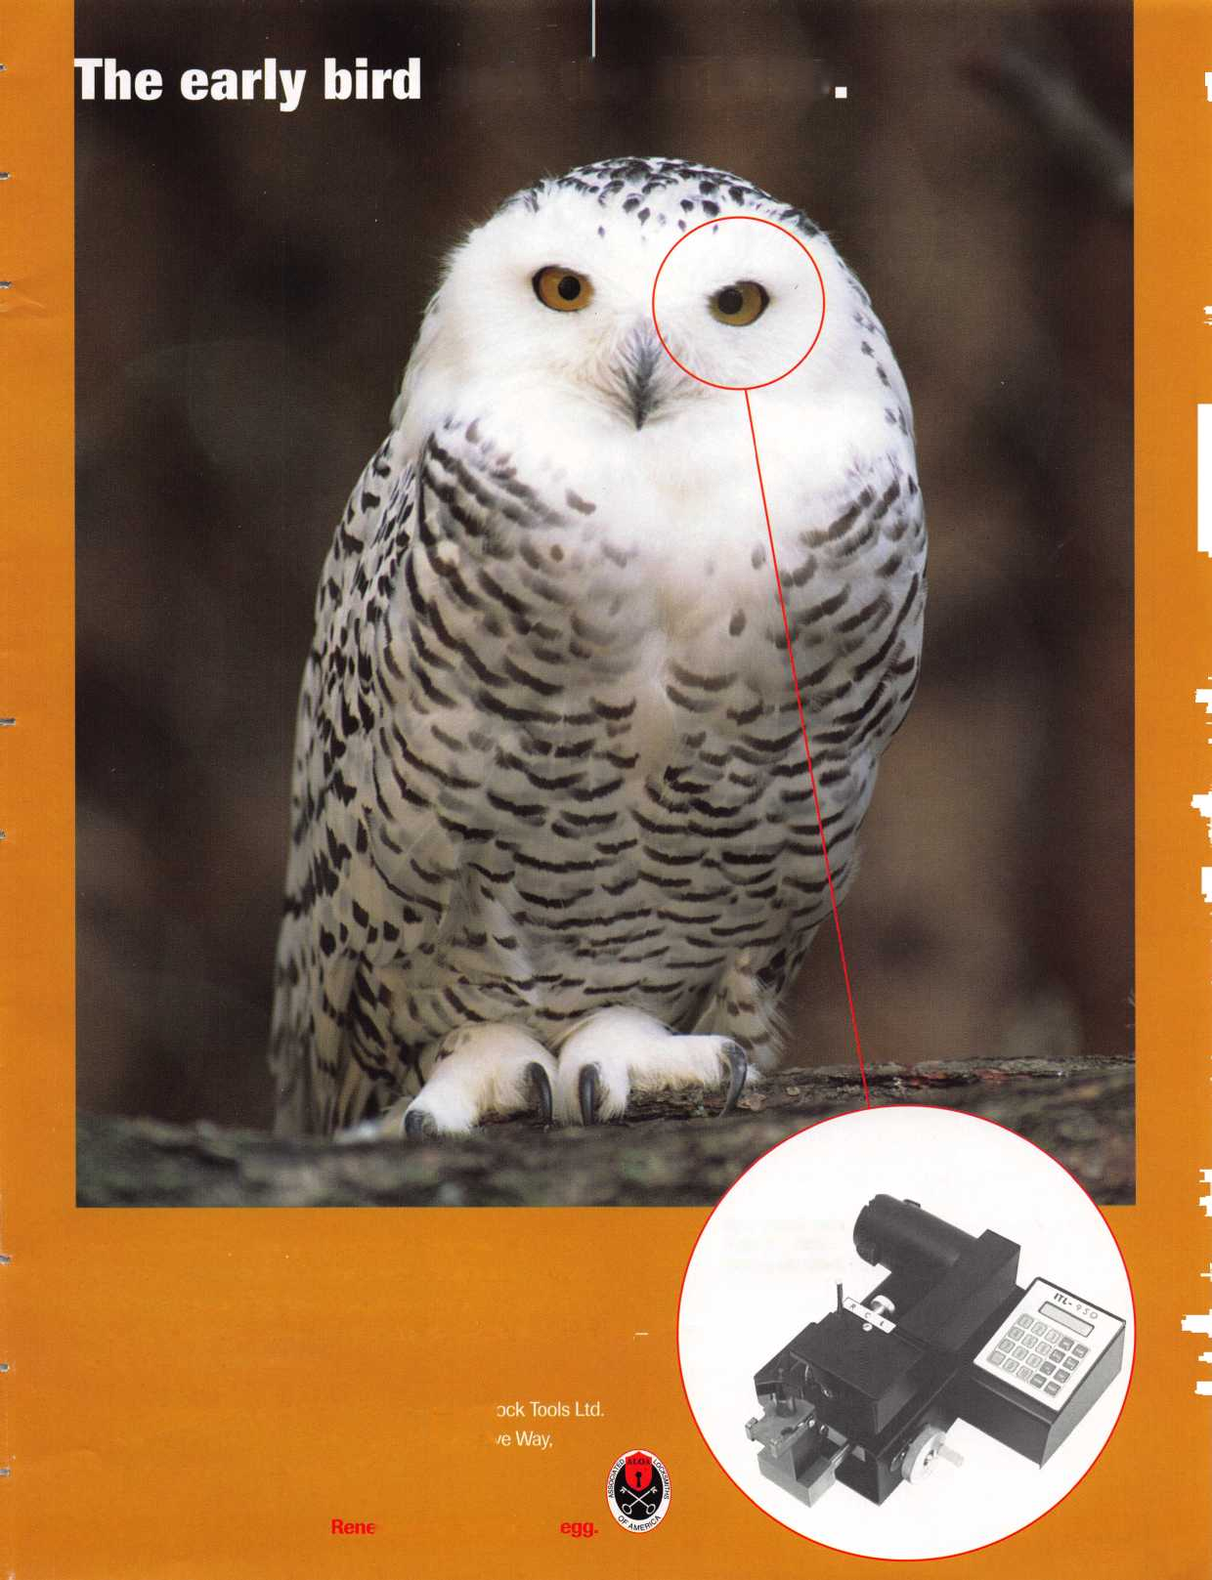

**DeCember** 98



Features

4

President’s Journey

By Dallas Brooks

16

Schiage Enters the 1-Core Market

An industry giant enters new territories. Get a preview of what’s in store.

By AJ. Hoffman, CML

image Vault Digital Security

Restoring the Past

woman’s passion for the past has helped her

the future of retro-door hardware.

Mike Emery

SCCfKL&di

19

Legislative Comment

The topic of “Licensing” is still as hot as ever.

Our Government Affairs Manager delivers some revelatory facts.

Tim McMullen

20

Now Hear This

Hold the phone! Here’s the inside scoop on “phone access”  
and how it can work for you.

Heidi Curnow

The Cover:

All eyes are on  
“Access Control.”  
This segment of the security  
industry is growing faster than  
ever and everyone’s looking to  
the future for the latest in  
access technology

Tune in for a review of new “video access” devices

from this Indiana manufacturer.

By James H. Glazier, CML

27

is There A Niche For You  
In The Booming CCTV Market

Lights, camera, action!

CCTV technology is expanding the horizons of access control.

By Paul F. Chandler, CRL

Art direction/design Valerie Rowe

30

Introducing e.Primus

Graphic design Lori Brennan

No, not a new droid in the next Star Wars flick. Learn more about Schlage’s new SASCAC lock.

By Paul F. Chandler, CRL

34

Best Type Interchangeable Cores, Part I

The first of a two part series, explaining tips and tricks of handling the original interchangeable core lock.

By Charles H. Cole, CML

December 1998

**Volume 44, Issue 11**

**Departments**

Upcoming Events

Plenty of meetings, classes and

PRP sittings

8

Security Marketplace  
The latest in hardware, tools  
and accessories

10

Applicants for Membership

Scheduled for clearance Jan. 1

11

Authors in This Issue

12

Core

Modern day, SAINTS lend helping hands

44

Back Page

36

Associate Members

40

Classifieds

42

Ad Index

mm

Keynotes

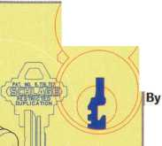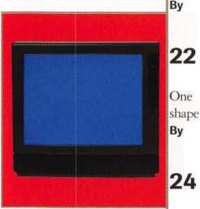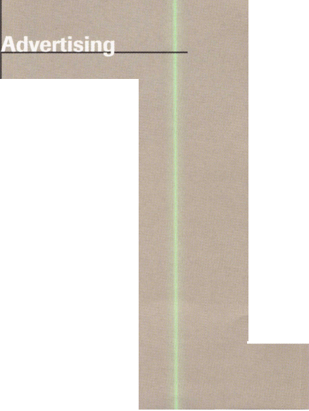

Technical Editor Editorial Advisor Advertising Sales

Contributing Authors

ALOA Professional Staff Executive Director

Operations Manager

Receptionist Comptroller Meetings Manager

Meetings Assistant Government Affairs Manager

[keynotes@anet-dfw.com](mailto:keynotes@anet-dfw.com) David Lowell, CML, CMS [david@aloa.ioffice.com](mailto:david@aloa.ioffice.com) John D. Cannon, CML [jdcannon@worldnet.att.net](mailto:jdcannon@worldnet.att.net) Marvin Diamond Lionhart Publishing (770) 431-0867, ext. 208 Jerome V. Andrews, CML Paul Chandler, CRL Claire Cohen, CML Brian Costley, CML, CMS Bob De Weese, CPL Ray D’Adamo, CML Sal Dulcamara, CML James Glazier, CML Daniel Graffeo, CRL, CMS Wayne Gurnee, CRL A.J. Hoffman, CML Ken Holmlund, CRL Ray Lusk, CML Mark Ohno Randy Simpson, CML Steven Spiwak, CRL Robert Stafford, CPL Dave Thielen

Charles W. Gibson, Jr., CAE [charlie@aloa.ioffice.com](mailto:charlie@aloa.ioffice.com) Mary May

[mary@aloa.ioffice.com](mailto:mary@aloa.ioffice.com) Margo E. Vela Kathy J. Romo Jessica Smith [jessica@aloa.ioffice.com](mailto:jessica@aloa.ioffice.com) Janelle Vergara Tim McMullen tim@aloa. iofiice .com

Additional contact information for the ALOA Board and most Keynotes authors are available through “Locksmith Search" on the ALOA website- [www.aloa.org](http://www.aloa.org) or by contacting the ALOA office at 3003 Live Oak Street; Dallas, TX 75204; (800)532-2562; FAX (214) 827-1810; e-mail [aloa@aloa.org](mailto:aloa@aloa.org).

President

Dallas C. Brooks (334) 826-8990

Secretary

John D. Cannon. CML (703) 960-6413

Directors, Northeast

James H. Glazier, CML (301) 831-5454 John G. Magee, III

1. 845-3434 William L. Young, CML
2. ) 647-5042

Directors, Southeast

Jeffrey S. Nunberg, CML, CMS (305) 324-8800 Donald R. Rule, CML (601) 324-2658

Directors, North Central

Mark E. Blum, CML, CPS (517) 482-5809 John J. Greenan (773) 486-2030

Director, South Central

Randy L. Simpson, CML (713) 780-7026

Directors, Southwest

Gordon Racine, CML (719) 384-4707 John I. Shandy, CML (303) 774-9791

Director, Northwest

Scott Henke, CRL, CPS (907) 248-3785

Director, Associate Members

Judd Penske (800) 634-5465

PRP/Education Manager

Education Assistant Membership Coordinator

Membership Assistant Chapters & Regional Associations Liaison

David Lowell, CML, CMS [david@aloa.ioffice.com](mailto:david@aloa.ioffice.com) Ashley Spencer Brandon Durrett [brandon@aloa.ioffice.com](mailto:brandon@aloa.ioffice.com) Jackie Arnett

Tim McMullen [tim@aloa.ioffice.com](mailto:tim@aloa.ioffice.com)



Mission Statement: The Associated Locksmiths of America, Inc. is dedicated to enhancing the professionalism, education and ethics among locksmiths and those in related sectors of the physical security industry. With approximately 10,000 members in the United States, Canada and the freeworld, ALOA is poised to help members obtain the knowledge, the strength, and the confidence to perform their role in the physical security field with pride and dignity. But it is only through active involvement and participation that ALOA can fully achieve its potential-and can help members to achieve theirs.

Policies: Keynoted is the official publication of the Associated Locksmiths of America, Inc. (ALOA). Keynotes® acts as a moderator without approving, disapproving, or guaranteeing the validity or accuracy of any data, claim, or opinion appearing under a byline or obtained or quoted from an acknowledged source. The opinions expressed by the authors do not necessarily reflect the official views of ALOA. Also, appearance of advertisements and new products or service information does not constitute an endorsement of products or services featured by the Association. The Association does not accept responsibility for the inaccuracy of any data, claim, or opinion appearing in this publication, due to typographical errors on the part of the authors, Association staff or its agents. Editor’s Note: This publication is designed to provide accurate and authoritative information in regard to the subject matter covered. It is provided and disseminated with the understanding that the publisher is not engaged in rendering legal or other professional services. If legal advice and other expert assistance is required, the services of a competent professional should be sought.

Authors’ Payment: Payment for eligible submissions to Keynotes will be based on the following criteria: topic, time spent and past contributions. Authors who regularly submit to Keynotes are generally paid a higher rate. The latter is especially true of authors who write to fit specific editorial needs and submit said copy by Keynotes deadlines. As a general guideline: Average payment for a 750 word, business or ‘light’ technical article would be $200. Payment for a 1500 word article involving significantly higher time and research efforts would be $400.

Payment will not be offered for articles submitted by ALOA employees or members of the ALOA Board of Directors (unless material is of a technical nature), nor for articles submitted by a company that promote that company’s products or services. ALOA reserves the right not to pay for articles submitted by an individuals) that promote a particular company’s products or services.

Disclaimer: The Associated Locksmiths of America, Inc., (ALOA), reserves the right to refuse any article for any reason. Additionally, ALOA reserves the right to edit, amend or modify any article submitted for publication in order to preserve technical accuracy, clarity, fairness or grammatical correctness. ALOA will make the best efforts to notify the author of any changes. The extent of ALOA’s liability for any article or information contained therein will be a notice of correction or retraction in the next possible issue.

Keynoted (ISSN 0277 0792) is published monthly except for the combined June/July issue by The Associated Locksmiths of America, Inc., 3003 Live Oak St., Dallas, TX 75204-6186. Telephone: (214) 827-1701; FAX (214) 827-1810: e-mail [aloa@aloa.org](mailto:aloa@aloa.org). Subscription rates for members-$ 15.00 per year. Second class postage paid at Dallas, Texas. POSTMASTER: Send address changes to: Keynotes, 3003 Live Oak St., Dallas, TX 75204-6186. © Copyright 1998, All rights reserved. No part of the contents may be reproduced or reprinted in any form without prior written permission of the publisher.

Non-Voting Directors

Jerome V. Andrews, CML (860) 621-3601 Steve G. Engel, CML, CPP (920) 731-5400

Trustees

David M. Lowell.CML, CMS (800) 532-2562 Breck H. Camp, CML (770) 455-6244 Henry H. Printz, CML (973) 538-2737 Leonard J. Passarello, CPL (416) 752-7210 Edwin Toepfer, RL (416) 225-5589

Chairmen off International Affairs

Laurence P. Mills/Australia (129) 958-0445 Hans Mejlshede, CML/Europe FAX (453) 139-1004

Past Presidents

1995-1997 David Lowell, CML, CMS 1993-1995 Breck Camp, CML 1991-1993 Henry Printz, CML 1989-1991 Evelyn Wersonick, CML, CPS 1987-1989 Leonard Passarello, CPL 1985-1987 Joe Jackman, CML 1983-1985 Stanley Haney, CPL 1981-1983 Louis LaGreco, CPL 1979-1981 John Kerr, RL 1977-1979 Clifford Cox, CML 1974-1977 Charles Hetherington 1972-1974 Gene Laughridge 1970-1972 William Dutcher, RL 1968-1970 Constant Maffrey, RL 1966-1968 Harold Edelstein, RL 1964-1966 William Meacham 1962-1964 Robert Rackliffe, CPL 1960-1962 Edwin Toepfer, RL 1956-1960 Ernest Johannesen

December 1998

Keynotes li

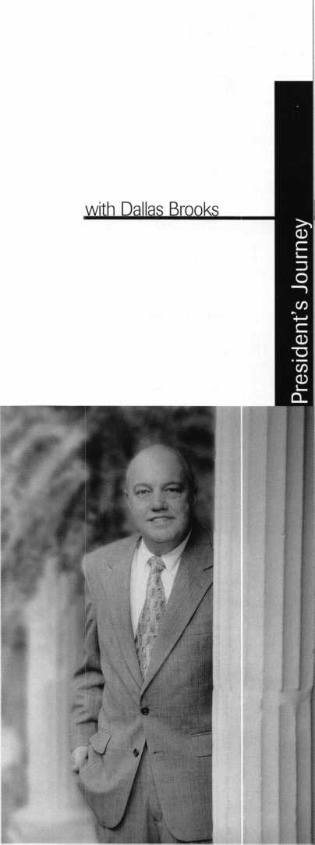

It’s easy to get sentimental this time of year. With the holidays upon us and a new year just around the corner, we should all reflect on the great things that 1998 gave us and think about making 1999 even better.

This past year was quite fruitful for our association. Considering that you selected a new board and voiced your opinions on numerous industry and association issues, 1998 was a year of unity within ALOA. With that, we should look towards 1999 with a renewed sense of pride and responsibility.

We also had some changes within our headquarters office, which have proven to be quite beneficial to everyone. The first that comes to mind is the addition of Tim McMullen as our Government Affairs manager. His extensive legal background and work with the Legislative Action Program should be commended. He has indeed become an asset to our organization and has helped many of us gain an even better understanding of our laws and how they affect each and every one of us as professionals.

In other staff changes, one of our long-standing technical experts (and a former president to boot), David Lowell, moved to our headquarters in Dallas, Texas, to assume the role of Education manager. With his experience as an instructor and knowledge as a CML and CMS, David worked hard this past year to organize the PRP as well as coordinate the necessary classes to prepare people for it. In addition to these tasks, he also made the time to double as technical editor for this very magazine, which he can attest to, is a job all its own.

Looking ahead to ’99, there are numerous things that will be of interest to many of you. For example, the ALOA web page will offer an interactive “ALOA Store” where members can purchase books and other helpful articles.

Another item of interest is the added resources within the PRP. 1999 will bring more sittings in more locations, an updated study guide and a compilation of past Keynotes articles to help in studying.

One of the board’s primary goals within the next year will be to devise ways to aid independent associations and chapters in working together.

As for Government Affairs goals, the department will keep its eyes open for press coverage of the industry for public relations aspects and to boost ALOA’s identity as an institution.

Plus, we have another convention to look forward to in ’99- In fact, it will be here before you know it, so keep your calendars open for July 25—31 and make your plans to join us in Cincinnati!

So much to look forward to, but for the present, all of you have a safe and happy holiday season! See you in 1999!

QtLc&Jl-

Dallas C. Brooks President

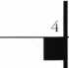

Keynotes

December 1998

|  |  |
| --- | --- |
| Kwok-kei Leung | 168 |
| Henry Raymond | 93 |
| Toshihiro Asano | 81 |
| Stewart Levine, CML | 67 |
| Mary Ohmit, CPL | 64 |
| Charles Robertson, CML | 63 |
| Yuriko Yanai | 61 |
| Jack Hobin, CPL | 51 |
| Allen Konrath | 49 |
| Salvatore Dulcamara, CML | 39 |
| Mveonq-Rae Cho | 38 |
| William Neff, CML | 35 |
| David Lowell, CML | 32 |
| Thomas Freehling, CML | 32 |
| Dana Barnum, CML | 31 |
| Jeanne Lodge, CML | 30 |
| John Heckman, CML | 29 |
| Barry Leas, CRL | 28 |
| J Thomas Hood, CML | 26 |
| Roy Renderer, CML | 25 |
| Danny Rudd, CPL | 24 |
| John Elliott, CML | 24 |
| Larrv Warnick, CML | 24 |
| James Watt, CML | 23 |
| Robert Carroll, CPL | 23 |
| Diana Barnum, CRL | 22 |
| Barbara Watt | 22 |
| David M A Federico | 22 |
| Robert DeWeese, CPL | 22 |
| Jim Williams | 22 |
| Eugene Altobella | 21 |
| Jerome Cohen, CML | 21 |
| Anthony Ramunno, CML | 21 |
| Lawrence F. Smith, Jr., CML | 21 |
| Charles Cole, CML | 19 |
| D Michael Lee, CPL | 18 |
| James Fowler, CML | 18 |
| David Harris, CML | 18 |
| Elvis Hammerschmidt, CPL | 18 |
| John Kerr, RL | 17 |
| Marian Swann, CRL | 17 |
| John Dorsey, CPL | 17 |
| Ronald Heidzig | 17 |
| Joseph Ferrero, CML | 16 |
| James Cawby, CML | 16 |
| William Grant, CRL | 16 |
| Scott Henke, CRL | 16 |
| Philip Rovenolt, CPL | 16 |
| Michael Robinson, CRL | 16 |
| Brian Reetz | 16 |
| Walter Lascar, RL | 15 |
| Thomas Vandersteen, CML | 15 |
| Gary Teams, CPL | 15 |
| William McElheney, CML | 15 |
| Rex Parmelee, RL | 14 |
| James Gruber, CRL | 14 |
| Keizo Takahashi | 14 |
| Russell Fuller, CRL | 14 |
| Edwin W Scott | 13 |

The Brightest And The Best

Peter Gauthier, CPL Frank Hartung, CML Jon Griswold, CML _ Paul Souber

Robert Rodocker, CRL_

Keiryu Tsukishiro

Rolando Bouza

Robert Duman, CML _ Lonnie McKinney, CML James Brickler, CRL _

Richard Sievers

Joe Lee, CRL

Daniel Landry

Eric Veal

Steven Spiwak, CRL

Herbert Dusenberry, CML

Raymond Lusk, CML

Robin Horsley

John Engel, CRL .

Donald Shiles

Thomas Demont, CML_ Ernest Wright

William Wickward, CML

Lester Brodsky

Joseph Whitaker, CPL

Dale Knowles, CPL

How can I join the President's Club?

You can earn membership in this prestigious club by recruiting just 10 new members for ALOA.

*Any ALOA member may participate.

What do I get?

When you recruit 10 members, you receive a handsome blue blazer with a President's Club crest. For each additional five members you recruit, you receive a lapel pin with gold-filled numbers, indicating your recruiting successes.

You also get the satisfaction of knowing that you are helping your association, helping your industry grow, and you are helping fellow locksmiths achieve success.

How do I get started?

Contact the ALOA office for a supply of applications (214) 827-1701 or FAX (214) 827-1810. One President's Club credit is awarded for each new applicant. Credit is awarded only after the membership application is approved. However, the credit will apply for the period in which the application is received. Failure to identify yourself as the sponsor on the application form at the time it is submitted to ALOA for processing will forfeit any credit.

*ALOA Board of Directors not eligible for membership in the President's Club.



Upnnming

Events

Dept

\s' ^ Indicates ALOA ACE Class  
Indicates PRP Sitting

DECEMBER

5

Grand Canyon Chapter Annual Meeting and Banquet Wyndham Garden Hotel Tempe, AZ 85281 Contact: John Ilk, CRL (602) 921-0123 (602) 425-9566 (after 5 pm)

10

ALOA Fall Board Meeting Dallas, Texas (214) 827-1701

12

**f/** ALOA PRP SITTING Georgia Chapter Atlanta, Ga.

Contact: Steve Gebbia, CML (770) 455-6242

1999

JANUARY

9

**ft** ALOA PRP SITTING Locksmith Security Association Detroit, Mich.

Contact: Sal Dulcamaro, CML (810) 791-5416 (810) 792-4021 fax

9

ACE Classes

Motorcycle Locksmithing Wyoming Chapter Casper, Wyo.

Contact: Gene Fieck, CPL (605) 642-4542 (605) 642-8946 fax

16-17

MBA Training

Combination Lock Technology I Nicholasville, Ky.

(888) 622-5495

20-21

MBA Training

Combination Lock Technology II Nicholasville, Ky.

(888) 622-5495

28-29

COMSEC 99 Washington DC (703) 519-6200

[www.asisonline.org/comsec.html](http://www.asisonline.org/comsec.html)

FEBRUARY

9-14

Texas Locksmiths Association Annual Convention and Trade Show Contact: Jim Hetchler (registration) (830) 606-1727 or Pat Titus (booth space) (210) 649-2166

14

**f/** ALOA PRP SITTING Texas Locksmiths Association San Antonio, Texas Contact: Wanda Robbins (210) 923-4381 (210) 977-8398 fax

20-21

^ ACE Class

Fundamentals of Master Keying Grand Canyon Chapter of ALOA Phoenix, Ariz.

Contact: John Ilk, CRL (602) 921-0123 (602) 921-0524

28

ALOA PRP SITTING Western Michigan Locksmiths Association, Kalamazoo, Mich. Contact: Terry L. Bussema, CRL (616) 381-5634 (616) 381-5654 fax

28

Local Organizations for Continuing Education—South Florida Locksmiths Association/

Florida Latin Locksmiths Contact: Jerri (days) (305) 944- 0469; or Wayne (evenings)

(305) 252-8355

MARCH

12-14

IDN Hardware Sales, Inc. Security Conference Cleveland, Ohio Contact: Fred Strasberger, John Kress or Bonnie Weston (800) 521-0955

20

**f/** ALOA PRP SITTING

MLANJ

Somerset, NJ

Contact: Bill Timann, CML (732) 424-7827

20-21

MBA Training Manipulation Nicholasville, Ky.

(888) 622-5495

18-21

**iv** ACE Classes

Sponsor: MLANJ Annual Convention Somerset, NJ (908) 889-3135 (908) 213-1267 fax [www.mlanj.org](http://www.mlanj.org)

APRIL

ii

ALOA PRP SITTING Montana Chapter of ALOA Butte, Mont.

Cooney s Locksmith Contact: Walter P. Cooney, CML (406) 782-0125 (406) 782-0125 fax

12-16

MBA Training

DoD Combination Locks

Nicholasville, Ky.

(888) 622-5495

17-18

MBA Training Professional Safe Drilling Nicholasville, Ky.

(888) 622-5495

MAY

3-8

SAFETECH ’99 Las Vegas, Nev.

(214) 827-7233

JULY

25-31

ALOA ’99 Security Expo Cincinnati, Ohio (800) 532-2562

AUGUST

27-30

MLA’s London Convention Contact: Dave Stokes 139 Wood Street Walthamstow, London, E17 3LX 01144 181 520 7450

2000

APRIL

5-9

MLANJ 2000 Annual Convention Somerset, NJ (732) 424-7827 [www.mlanj.org](http://www.mlanj.org)

MAY

5-10

SAFETECH 2000 Birmingham, Ala. (214) 827-7233

JULY

17-22

ALOA 2000 Las Vegas, Nev. (214) 827-1701

2001

MARCH

28-April 9

MLANJ 2001 Annual Convention Somerset, NJ (732) 424-7827 [www.mlanj.org](http://www.mlanj.org)

JULY

15-21

ALOA 2001 Security Expo Baltimore, Md.

(800) 532-2562

2002

JULY

21-27

ALOA 2002 Security Expo Rosemont, 111.

(800) 532-2562

m

6**| *Keynotes***

December 1998



LOCKMASTERS: **inc**

Providing quality tools

.for generations to come!

l left to right, Lucas, son of Kevin Moores; Wyatt, son of Brian Lamb; Madeline, of Mark Miller; Andrew, son of Wes Day; and baby Tyson, son of Steve Robinson.

call 1-800-654-0637 ext. 498

to order a FREE copy of our 1999 Tool Catalog  
featuring New Safe Tools, Pin Kits, Key Machines,  
Automotvie Opening Tools and more!

email: sales [info@lockmasters.com](mailto:info@lockmasters.com)

Reader Service #2

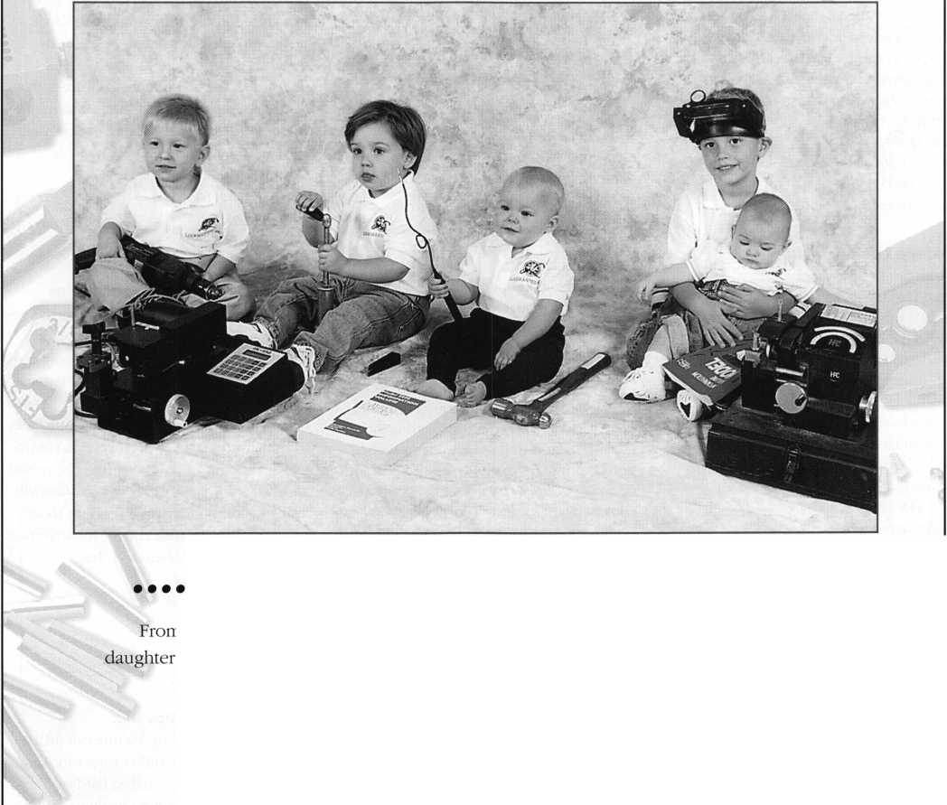

Security

Marketplace

American Lock Company

American Lock Company introduces a 2- 3/4" solid brass rectangle lock with a pro­tected, locking- bolt shackle. The lock, also known as a “warehouse lock,” is used to secure self-storage facilities, garages, storefront roll-up doors and coin operated devices, such as newspaper vending machines. It is designed to endure harsh weather conditions and temperature extremes.

American hock 3400 W. Exchange Crete, IL 60417-2099 (708) 534-2000 (708) 534-0531 fax Reader Service #14

Chicago Lock Company

Chicago Lock Company recently intro­duced BarLOC, which features a rotary disk tumbler mechanism with a front anti-drill plate and a hardened steel body and shackle. It’s offered in three body sizes and designed with interchangeable shackles. The shackles, available in three lengths for each body size, are easy to change. A large plastic key han­dle provides ease of operation. The key may also be inserted in either direction.

Chicago Lock Company (800)445-3204 Reader Service #15

Sensormatic

Sensormatic Electronics Corporation released OCURE 800 version 3.0 and OCURE Trac, the first fully integrated security management system coupled with radio frequency identification (RFID) asset tracking and protection solution. OCURE 800, combined with OCURE Trac hardware, is the only system that can document the movement of stationary and portable assets and offer detail reporting of when, where and with who an asset left a secured area **Sensormatic**

http:llxvtvw.sensormatic.com Reader Service #16

Ace Lock and Security Supply

Ace Lock and Security Supply has made available the FRA-2001 Computerized Key Machine manufactured by Framon Manufacturing. It offers locksmiths the opportunity to simply select either the key



manufacturer or the key code and then press “enter” to cut the key. A full code database is included. Framon’s FRA-2001 has a one- year parts, labor and freight warranty and the control box has a lifetime warranty. The machine requires a 386 or higher PC-com­patible computer running either Windows ’95 or Windows 3.1. Twenty megabytes of disk space are needed for the program, and a 3 1/2" floppy drive is required for installation. **Ace Lock and Security Supply 565 Rahway Avenue Union, New Jersey 07083 (800) ACE-LOCK (800) ACE-FAX4 fax acelock @acelock.com Reader Service #17**

Streamlight, Inc.

The Syclone is now available in a rechargeable model for the professional law enforcement market. The rechargeable Syclone, like the previously released dispos­able battery-powered model, features two bulbs that make it especially useful for criti­cal lighting tasks. The primary bulb is a bi­pin “black dot” krypton that pierces smoke, fog and mist as well as generates a spot to flood beam of up to 6,000 candlepower for up to 2.5 hours of continuous use between charges. The alkaline battery powered Syclone produces the same powerful beam and has a run time of 3.5 hours on 4 AA batteries.

The Syclone is also equipped with a back-up

krypton safety bulb that can be switched on

for emergency or general use lighting.

Streamlight

(800) 523-7488

wtvw.streamlight.com

Reader Service #18

Rose Lock Products

Cylinder Shield has a wrench proof collar that protects the mortise cylinder from tam­pering and burglary. It can be applied on mall gated and store fronts. It has an aluminum body and cover. It is assembled with case has a 1.8" thick rotating cover that protects the entire mortise cylinder and the keyhole from dirt, grime, harsh cleaning chemicals and the weather. **Rose Lock Products PO Box 100372 Nashville, TN 37224-0372 (615) 292-5537 (615) 834-5975 fax Reader Service #19**

Craftsman Power and Hand Tools Catalog

The new Craftsman and Power and Hand tools catalog showcases over 650 new Craftsman tools and 70 new additions to the Craftsman Professional tool line. New products introduced in the ’98-’99 catalog include a line of professional storage chests. Also included is the industry’s first 5 2-inch, 13 drawer ball bearing mobile tool cart with an electronic remote control locking system using rolling code technology. For a free copy of the Craftsman Power and Hand Tools Catalog:

Sears Shop at Home Services (800) 948-8800 Reader Service #20

Moniteq Research Laboratories

Moniteq Research Laboratories introduced a single door access controller that greatly simplifies the task of retrofitting existing doors for high security in both government and industrial applications. It is compatible with heavy locking devices. Crypto Lock includes a weatherproof stainless steel keypad, control panel and built in power supply. The power supply has the capacity to power commercially available locking devices, including those requiring high in-rush current for activation. **Moniteq Research Laboratories, Inc.**

7640 Fullerton Road Springfield, VA 22153 (800) 989-9891 (703) 569-0196 Reader Service #21

Marray Enterprises, Inc.

DOR-COR Drilling Fixture can drill a 3/8" raceway within 1/8" of center for easy, safe and consistent electrified hardware installations. It mounts to hanging doors and drills from the hinge mortise to the lock prep to wire power transfer hinges and elec­trified access hardware on 36" commercial grade wood and composite doors.

Marray Enterprises 1128 Walsh Avenue Santa Clara, CA 95050 (800) 500-0213 (408) 970-8767fax Reader Service #22

***Keynotes***

December 1998

Security

Marketplace

Corbin Russwin

Corbin Russwin introduced CL3300, its newest Grade 1 Key-in Lever Cylindrical Lockset. The series features a patented lever release design that allows the lever to disen­gage when pressure is applied in the locked condition, the latest in vandal resistance.

The new CL3300 Series, which carries a three-hour UL fire rating, replaces the CL3400 Series Key-in-Lever Lockset.

Corbin Russwin

Yale Security Group Americas

1902 Airport Rd.

Monroe, NC 28110 Reader Service #23

GBC/CCTV Corporation

GBC TKO-450/935C aka “The Brute” are discreet cameras for use indoors or outdoors. Both black and white and color models feature a 1/3 inch CCD camera that is internally adjustable on a three-way gimbal. A corner mount is also included that features a ball joint for external adjustability.

This camera comes standard with a clear polycarbonate window, but an optional gray window is available if concealment of the camera is desired.

CCTV Corp.

280 Huyler Street Hackensack, NJ 07606 (201) 489-9595 (201) 489-0111 fax Reader Service #24

Secuvitron

Securitron Magnalock Corporation presents the UnLatch motorized electronic strike. It pushes the door latch into the lock body releasing the door. The UnLatch maintains continuous deadlatch security. The device takes the place of traditional electric strikes, by allowing the installation into an ANSI 4 7/8" cutout without doorframe modification. It also comes with a built-in monitor that can signal the door is latched. **Securitron (702) 355-5625 (702) 355-5636fax [info@securitron.com](mailto:info@securitron.com) Reader Service #25**

Labor Saving Devices

Labor Saving Devices, Inc. announced the release of its new products catalog featuring the company’s full line of specialty tools for the professional wire/cable installers. The brochure includes over 15 new products including installers kits, new specialty drill bits and saws, heavy duty cable running kit and cable pulleys for the commercial installer, a complete line of pick-up and inspection tools, 15-in-one screwdriver with standard or tamperproof bits, high quality and cable organizers. Ten pages are dedicated to tips and techniques on how to handle recurring installer problems.

Labor Saving Devices, Inc.

5678 Eudora St.

Commerce City, CO. 80022-3809 (800) 648-4714 (303) 287-9044 fax Reader Service #26

Secura Key

Secura Key has announced the new SK-NET Access Control software which, together with the 28SA-Plus Smart Access Control Units, controls up to 128 doors. It has features like graphical time zone displays and drag and drop creation of access groups. The ENTRACOMP 28SA offers True Global Antipassback, which tracks cardhold­ers’ IN and OUT status between multiple 28Sas, even without a PC on-line. SK-NET communicated to the 28SA-Plus via a high speed RS485 single twisted pair network, which allows cable distances of up to 4,000 feet, with any system topography: daisy chain, star, “T”or stubbed.

Secura Key 20447 Nordhoff St.

Chatsworth, CA 91311-6112 (818) 882-0020 (818) 882-7052fax [mail@securakey.com](mailto:mail@securakey.com) http:lltvunv.securakey.com Reader Service #27

Olympus America Inc.,

Industrial Products Group

A portable Digital Video Microscope, Model DVM-1, that can freeze and store more than 500 magnified images has been introduced by Olympus America Inc., Industrial Products Group. The DVM-1 allows operators to perform nondestructive visual inspections of surfaces that cannot be viewed with conventional microscopes. Lenses range from 10X to 70X zoom, to 100X, including a 100X 6mm side-viewing probe, plus contact and noncontact heads. **Olympus America Inc., Industrial Products Group Two Corporate Center Drive Melville, NY 11747-3157 (516) 844-5888 Reader Service #28**

Jensen Tools, Inc.

The “6-In-l Screwdriver/Magnet” allows fasteners to be rescued from tight spots. It telescopes to 23 inches, and the magnet is capable of lifting over half a pound. Equipped with a rubberized Quadra Drive Handle, it also comes with a removable bit organizer and includes six 1" bits.

Jensen Tools, Inc.

7815 S. 46th Street Phoenix, AZ 85044-5399 (602) 968-6241 (602) 438-1690fax Reader Service #29

Dorma Group North America

The 9000 Series fire and panic exit devices by Dorma Architectural are designed for high-use, institutional applications.

The series includes rim, mortise, concealed and surface vertical rod options. All devices within the series are ANSI Grade I, UL- listed and available in panic and fire versions to meet applicable requirements. The devices are equipped with partial length touch bars which permit field installation of options like cylinder dogging and exit alarm.

Dorma

Dorma Drive, Drawer AC Reamstown, PA 17567-0411 Reader Service #30

Keynotes

9

December 1998

Applicants

For Membership

|  |  |
| --- | --- |
| USA | MARYLAND |
| ARIZONA | Finksburg |
| Phoenix | 028577, Robert C Rudolph, AP |
| 028552, Carlos A Matamoros, A | SPONSOR: James Glazier  028576, John J Stasik, AP |
| CALIFORNIA | SPONSOR: James Glazier |
| San Francisco |  |
| 028583, Bernabe G Lara, A | MAINE |
|  | Waterville |
| FLORIDA | 028563, David P Hallee, A |
| Ft Lavd | SPONSOR: Barry Leas |
| 028553, Donald LOliff, A  Orlando | MINNESOTA |
| 028569, Jimmy D Ryals, A | Cambridge |
| SPONSOR: Jimmy Haveard | 028568, Robert Girga, AP |
| Palm Bay | SPONSOR: John Heckman |
| 028566, Matthew J Carrick, A | Little Canada |
| Stuart | 028550, Paul M Kostelki, A |
| 028582, Patrick Connolly, A | SPONSOR: David Paulsrud |
| SPONSOR: William Partington | NEBRASKA |
| GEORGIA | Omaha |
| Augusta | 028584, Andy Siders, A |
| 028551, Henry D Ragland, A  Norcross | SPONSOR: Dallas Brooks |
| 028580, Joseph E White, AP | NEW HAMPSHIRE |
| SPONSOR: Joseph Mitchell | N Conway  028560, Brian J Hill, AP |
| ILLINOIS | SPONSOR: Robert Day |
| Justice |  |
| 028573, Perry M Stillwell, AP | NEW MEXICO |
| Rock Island | Albuquerque |
| 028545, Jerry G Bennett, A | 028548, Thomas D Cole, A |
| SPONSOR: Ronald Malmberg | SPONSOR: Charles Cole |
|  | 028565, Joseph M Dorn, AP |
| LOUISIANA |  |
| Metairie | OHIO |
| 027098, Philip L Honses, A | Aurora |
| SPONSOR: Ajae Hardeman | 028575, Wiley C Frank, A |
| Slidell | SPONSOR: James Glazier |
| 028585, Donald A Tucker, A | Dayton |
| SPONSOR: Jearl Hancock | 028578, Jerald T Sparkman, A SPONSOR: William Beatty |
| MASSACHUSETTS | Plymouth |
| Westfield | 028546, William L Robinson, AP |
| 028567, David J Saltmarsh, A SPONSOR: Russell Fuller | SPONSOR: Ed Levitt |



***I he following applicants are scheduled for clearance as members of  
ALOA. The names are published for member review and comment prior to  
January 1, 1999, to ensure applicants meet standards of ALOA’s Code of  
Ethics. Protests, if any, should be addressed to the Membership Department  
and must be signed. Active Membership applicants (A) have worked in the  
industry two or more years. Allied Membership (AL) applicants are not  
locksmiths, but work in a security-related field. Apprentice Membership (AP)  
applicants have worked in the industry less than two years. A***

|  |  |
| --- | --- |
| OREGON | JAPAN |
| Portland | Edogawa-Kujokyo |
| 028564, Jim E French, A | 028571, Imamura Tsuneyuki, A |
| SPONSOR: Darrell Driver | SPONSOR: Keiryu Tsukishiro 028572, Suzuki Yoshiharu, A |
| SOUTH CAROLINA | SPONSOR: Keiryu Tsukishiro |
| Fort Mill | Fukui |
| 028562, Charles A Pope, A | 028581, Haruhisa Ogawa, A |
| SPONSOR: Granger Marley | SPONSOR: Makoto Yoshizawa |
| 028561, Georgia S Pope, A | Musashino-City,Tokyo |
| SPONSOR: Granger Marley | 028554, Haruki Ohtsuki, A  SPONSOR: Toshihiro Asano |
| VIRGINIA | Utsunomiya, Tochigi |
| Arlington | 028570, Ohmori Kenichi, A |
| 028555, Christopher J Broadwater, A SPONSOR: Michael Groves | SPONSOR: Keiryu Tsukishiro |
| 028556, Paul M Carchia, A | TOKYO |
| SPONSOR: Michael Groves | Kouto-Ku |
| 028558, Graham C Coats, A | 028579, Minoru Tabata, A |
| SPONSOR: Michael Groves  028557, Santos Sorto, A | SPONSOR: Toshihiro Asano |
| SPONSOR: Michael Groves | NEW ZEALAND  AUCKLAND |
| AUSTRIA | Newton |
| Eijon, Asturias | 028547, Andrew J Barltrop, A |
| 028549, Joaquin S Garcia, A SPONSOR: Steve Gallagher  CANADA  BRITISH COLUMBIA  Burnaby  028574, Tommy M Yeung, A SPONSOR: Chung Lee  HONG KONG  Hong Kong  028559, Hon-ming Wong, A SPONSOR: Lui Chung-Kin | SPONSOR: Charles Barltrop |

J

Keynotes

December 1998

ALOA SCHOLARSHIP FOUNDATION, INC.

ALOA/SAVTA SCHOLARSHIP APPLICATION  
3003 Live Oak Street; Dallas TX 75204; (214) 827-1701

Please print or type

NAMEPRP LEVELALOA/SAVTA#

HOME ADDRESSCITYSTATE ZIP

HOME PHONE -DOBEDUCATIONAL LEVEL (YEARS) DEGREE, IF ANY

PRESENT EMPLOYERWORK PHONEFAX WORK ADDRESSCITYSTATE ZIP

POSITIONFULL TIME PART TIME TAKE HOME PAY

LENGTH OF TIME IN LOCKSMITHINGOWNER/SUPERVISOR’S FULL NAME MEMBERSHIP IN TRADE ASSOCIATIONS (LIST BY NAME)

MARITAL STATUSSPOUSE’S OCCUPATIONSPOUSE’S TAKE HOME PAY

COMBINED HOUSEHOLD ADJUSTED GROSS INCOMENUMBER OF DEPENDENTS

CLASSES DESIREDDATE OF CLASSES

ORGANIZATION SPONSORING CLASSES: ALOA SAVTA OTHERLOCATION

ALOA Scholarships are granted to selected individuals desirous of entering the locksmithing field or to selected individuals already in the locksmithing field who wish to improve their professional skills through education.

Applications for classes being taken locally must be received a minimum of 60 days prior to the date of the class, and will be reviewed as they are submitted. Scholarships for classes at the ALOA or SAVTA convention will be awarded each year at the ALOA Scholarship Foundation meeting preceding the convention and must be received by March 1 each year.

Please attach to this form a letter stating your reason for applying for a scholarship, what you plan to do with the knowledge you obtain and any other information you feel may be helpful to the scholarship board in making its decision. In addition, attach three letters of reference from individuals who have personal knowledge of your background and character. The letters should contain their names, addresses and phone numbers. It would be helpful if at least one of these references is an ALOA or SAVTA member. Also, please provide a copy of your most recent tax return.

All scholarship recipients will be required to provide a 3 X 5 inch photograph of themselves.

APPLICATION CHECK LIST

Only complete applications will be considered for scholarships. An application is considered incomplete unless ALL of the above requested information is received before the deadline: 60 days prior to the date of a class or March 1 for ALOA/SAVTA convention classes. Please send this application after checking off each of the below.

* I have filled in each blank on this form.
* I have written and enclosed a letter explaining my reason for applying.
* I have enclosed three letters of reference.
* I have enclosed a copy of my most recent tax return.
* I am submitting this in time to be received 60 days prior to the date of a class or by March 1 for ALOA/SAVTA convention classes.

CERTIFICATION OF APPLICANT:

I certify that the information contained herein, and all supplemental forms are complete and correct to the best of my knowledge. I further certify that if i an selected as a scholarship recipient i will use the knowledge gained for the improvement, development and advancement of the locksmithing profession.

SignatureDate 4/98

Keynotes

Authors

Dept

Paul Chandler, CRL, is the manager of the Electronic Security Department for I.D.N.- ACME in Houston, TX.

Charles H.

“Charlie” Cole has been a member of ALOA for over 20 years. He was selected as the Keynotes Advisor of the Year and also passed the PRP tests to become a CML in 1986. He answers the code hotline for Locksmith Ledger from his home in Albuquerque, New Mexico, assisting lockmsmiths nationwide with codes and technical information.



Heidi Cumow is the Marketing Manager for Aiphone Corporation.

I Sal Dulcamaro,

CML, has been in the locksmith  
business for over 23 years. He is the  
president of All Pro Security, Inc. in  
Michigan and has been an ALOA  
member for 16 years. A past president  
of the Locksmith Security Association  
of Michigan. Sal currently serves as  
editor of the association newsletter. He  
was named "Keynotes Author of the  
YeaP’for 1996 and 1997.

I Mike Emery is the

Managing Editor of Keynotes and  
a freelance music, film and real  
estate writer.

James Jim” Glazier

is a retiredpolice officer and operated  
Security Plus in Mount Airy, Md. He  
is currently serving on the ALOA  
Board as a Director of the Northeast  
Region.

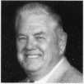

“A. J. ” Hoffman is a

recognized authority on cylinders and  
keying. He instructs Comprehensive  
Interchangeable Core, a two-day class  
covering all brands of cores. An avid  
lock collector since age six, he was a  
commercial locksmith before entering  
lock manufacturing in 1982. He has  
served several terms as member-at-  
large to the ALOA board. In 1988 he  
was inducted into the Locksmith  
Ledger Security Hall of Fame and  
received the coveted Philadelphia  
Award in 1992. He is currently the  
Product Manager for Cylinders and  
Key Systems for both Schlage and  
Falcon Lock, divisions oflngersoll-  
Rand. He has held similar positions  
with Kaba and Corbin Russwin.



Tim McMullen

oversees legislative affairs for  
ALOA. He is a graduate of the  
District of Columbia School of Law  
and has an extensive background  
in legislative work.

Training

Certification

For a FREE VATSmith information packet and  
locations of BWD Certified VATS Centers  
Cal!

800-647-4926

See us at [www.alllock.com](http://www.alllock.com)

Reader Service#3

One Slop Shopping



**Rugged, Dependable Security Products.**

Providing solutions to your

access control dilemmas.

I For information

1 * ef°ur.

^ ^ Electronic

*• Access

Department

today!

Toll Free: 800-282-2837 Fax: 800-447-2299



Warehouses in: Largo, FL; Miami, FL;  
Oakland Park, FL; Charlotte, NC; and Atlanta, GA.

**Serving the Security Industry Since 1946.**

Reader Service #4

December 1998

Keynotes

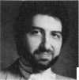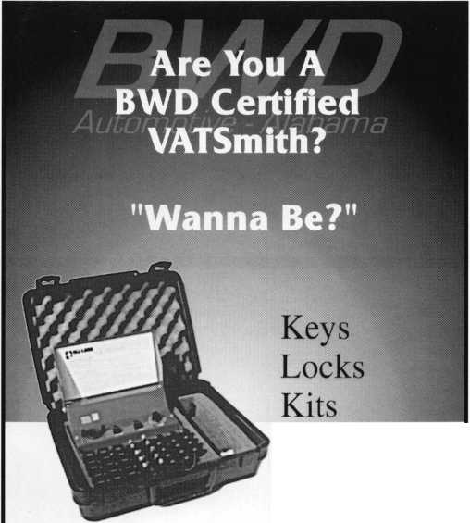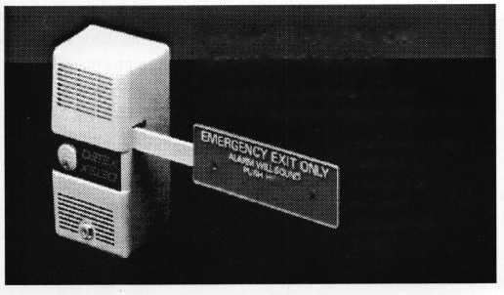

High road to China

...They were kind of shocked to learn that U.S. police aren’t more_

d'emandin^^

these things in almost any way they wantio——

In a cultural exchange that revolved around security applications, ADI’s Stan Martin nnrf with the Min inn \\ i »f Pi il >1 lr

provinces in attendance and they were very interested in learning how alarm systems were set up and what the relationships were

Security of the People’s Republic of China.

Martin, the vice president of Industry Relations at ADI, met with various members of the Chinese government and police department to discuss an assortn^^ security topics.

“They were looking for someone who understood alarm systems, had worked with police departments, ordinances, standards and the interface between different segments of the public and private sectors, “ says Martin.

Among the topics discussed by Martin were commercial applications, end user demands, alarm company issues, current police issues and false alarm problems.

“Everyone was very receptive,” he says. “We had police departments from 13

between the police and end users. They were kind of shocked to learn that U.S. police aren’t more demanding as far as following standards in installing systems and that dealers put these things in almost any way they wantta*1^—-—_

Martin was in China for a total of 10 days and describes the event as both a personal and professional adventure.

“Culture shock would be an understate­ment,” he says. “Speaking for myself, I was expecting a more stoic, serious type of people, especially the police. What I found was that these people were incredibly warm, had a great sense of humor and very caring.

It was completely different from what I expected.”

— Mike Emery



**Ingersoll-Rand’s architectural hardware, Schlage recently launched its new website at [www.schlage.com](http://www.schlage.com). ...Security Lock Distributors will conduct factory certification classes in different cities across the country. Interested parties should call (800) 847-5625 for details. ...This years International Hardware Show organized by the Hong Kong Trade Develop Council set an attendance record. The event, which was held from October 29—31, drew 6,200 international traders. ...UsCan Lock Distributors is now known as Security Distributors, Inc.**

Keynotes

December 1998

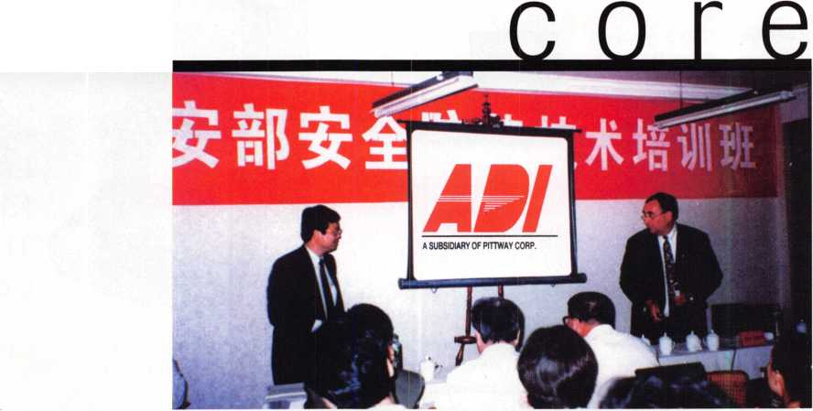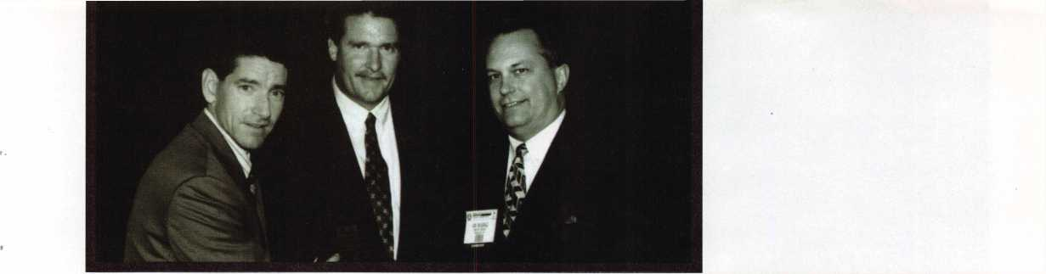

• Hardware pays off

Congratulations to Sentry Group. The company took 1st and 2nd place packaging  
awards in the Automotive Supplies, Pet Supplies and Miscellaneous category at the 24th  
Annual International Hardware Week Packaging Exposition conducted at the 1998  
International Hardware Show in Chicago. In attendance from Sentry was Director of  
Marketing, Joe Oelgoetz. Pictured next to him are Jack Kelleher (left), secretary/ treasurer of  
the Young Executive Council AHMA, and John M. Council (right), chairman of the Young  
Executive Council AHMA.

The Packaging Exposition, sponsored by the American Hardware Manufacturers  
Associations, reviewed 800 entries and announced 54 product packaging and merchandiser  
awards. Entries were judged by retailers and wholesalers from the hardware trade and  
were evaluated on the basis of information communicated, visual appeal, desirability and  
overall effectiveness.

ALOA board election results

**The meeting of the members of the Associated Locksmiths of America, Inc., was held on Oct. 30, 1998, at 10:00 a.m. CST at the association headquarters located at 3003 Live Oak Street; Dallas, Texas 75204.**

**CPA Todd M. Brookshier presented proxies from ALOA members. The election results are as follows:**

**Secretary**

**John D. Cannon, CML**

* And the winner is...

Congratulations to all of the winners at SIA’s New Product Showcase. Here’s a list of the products that received top honors.

NPS Product

Achievement Award Winners

* Securitron Magnalock Corporation— “UnLatch Motorized Electric Strike”
* 8x8, Inc—“Remote Surveillance Module (RSM-1500)”
* Silent Witness-“V100 Bullet Resistant CCTV Camera System”
* Mas Hamilton Group—“PowerLever”
* Sentrol-“ESL 700 Series Projected Beam Smoke Detector”
* C&KSystems, Inc-

“DT-900 DUAL TEC Motion Sensor”

• execs

Foreman’s Award Winner

* Radionics, Inc.-“HPM-110”

Dealer’s Choice Award

* UPLINK-“DigiCell 1600”

Judge’s Choice Award (SIA’s Best-of-Show Award)

* 8x8, Inc .-“Remote Surveillance Module (RSM-1500)”

Specifier’s Choice Award

* Securitron Magnalock—

“UnLatch Motorized Electric Strike”

Practitioner’s Choice Award

* 8x8, Inc.-“Remote Surveillance Module (RSM-1500)”

Directors, Northeast

James H. Glazier, CML John G. Magee, III William L. Young, CML

Director, Southeast

Donald R. Rule, CML

Director, North Central

Mark Blum, CML, CPS

Director, South Central

Randy L. Simpson, CML

Director, Associate Members

Judd Penske

(For a complete listing of ALOA board members, see the board list on p. 3)

In addition to the board elections, BYLAWS Change #1 and BYLAWS Change #2 both passed.

The next ALOA election will be held in spring 1999, date TBA.

Longtime technical service specialist at Schwab, **Bill Woodward** has announced his retirement after 25 years of service. Schwab has also announced that **Penny Golden** will be promoted into technical services. ...Wells Lamont Industrial presented **George Tomaskie** with the Sales Growth

Achievement award. Also at Wells Lamont, **Mark Horton** was named district sales representative and **Chris Corder** has been promoted to regional sales manager.

December 1998

Keynotes

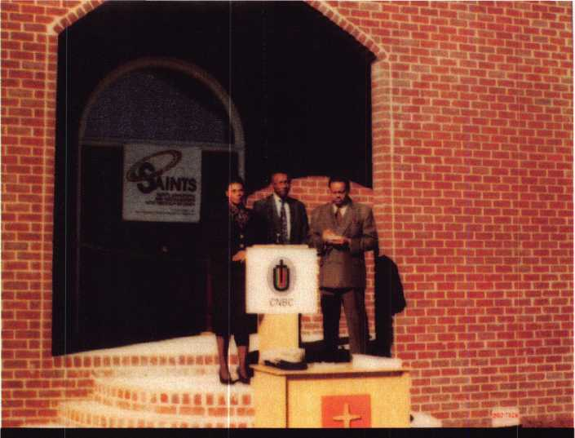

spotlight news

• SAINTS are marchin’ in

Hate crimes and church burnings have become increasingly visible  
within the last year. In direct response to such occurrences, the Congress of  
National Black Churches, Inc. (CNBC) has entered into a partnership with  
the Security Industry Coalitions SAINTS (Safety Awareness and Indepen-  
dence Now Through Security) program.

Through SAINTS, the Security Industry Coalition will donate security  
system equipment, installation, central station monitoring and security  
assessment and educational services to the CNBC.

Included in the security industry coalition are ALOA, the Security  
Industry Association (SIA), the National Burglar and Fire Alarm Associa-  
tion (NBFAA), and the Central Station Alarm Association (CSAA).

The first of donation of security materials took place at the Oak Grove  
CME Church in Elko, Ga. in late October.

“We had intrusion detection equipment and smoke detectors installed as  
well as the kind of fire safety equipment that will alert people when it’s  
time to vacate the premises,” says Richard Chace, one of the coordinators  
behind SAINTS and the director of communications and public affairs with  
the Security Industry Association. “From ALOA, we had a donation of  
better lock hardware than the church was equipped with. Monitoring is  
also being supplied as well as various educational services to teach parish-  
ioners the benefits of security and bow to maintain it in their own homes.”

According to Chace, more churches are in line for donated goods, but he  
also says that there are still challenges to be faced as far as maintaining the  
strength of this program.

“I think the biggest challenge here is the organizational challenge,” he  
says. “You’re dealing with a coalition of very dedicated industry members  
who are dedicating their time, energy and services. There are 200 churches  
that we’ll be outfitting within the next 14 months or so. It’s a tremendous  
organizational undertaking. Getting the commitments has been easy, thus  
far. People have been very generous with their time and donation of  
services. Right now, we just have to make sure everything keeps  
moving smoothly.”

— Mike Emery

* prp

CRLs

Valerie F. Betschman, Monroeville, Ohio Matthew S. Eggleton, Lenoir, NC Glenn E. Fenzel, Cleveland, Ohio George E. Ferreira, Dartmouth, Mass.

Robert W. Gorton, Winoski, Vt.

Clay Hart, Parma, Ohio Kirk D. Lukenbill, Logan, Utah Bruce A. Loyd, Mexico, Mo.

Marc. J. Lozier, Gales Perry, Conn.

Angelo J. Savage, Lansdone, Maryland Karen E. Snow, Truro, Mass.

Martin C. Wexler, Thomson, Conn.

Curtis Wycoff, Osawatomie, Kan.

CPSs

Leslie Harvey, Portland, Ore.

Michael Potter, East Canton, Ohio

* regions

The Greater Philadelphia Locksmith Association (GPLA) is holding its Holiday Party Friday, Dec. 11. For more information, call Bob Schuetrumpf at (609) 486-9280 or Mary Armold at (609) 665-0464. .. The Central Florida Locksmith Association is holding its holiday festivities, a Covered Dish Dinner on Dec. 16. ...On Jan. 9, the Wisconsin Indianhead Chapter of ALOA will hold its annual banquet at the Ramada Inn in Eau Claire, Wis.

• obituaries

ALOA regrettably bids farewell to some its valued members. Our hearts and prayers go out to the friends and families of the following:

Alex Basting was an ALOA member for 20 years. He was 75-years-old.

Kenji Wada hailed from Yokohama, Japan and was an employee of Alpha Corporation. He was 68-years-old.

Keynotes

December 1998



**MicroKey" «**

**Presents** 1 **A Golden Sales**

*I* ake good care of your /

customers with high $

security technology that \ *yf* /\

creates repeat business \ . <^4/

for you. *\* +

The computerized I

MicroKey Series is *' A*

easily installed in new jm

or retrofit construction

applications without

electrical wiring. Easily

expandable, it is adaptable to

sma// or mid-size projects.

It accommodates mortise or cylindrical door prep conditions.

Winfield's sophisticated engineering has instilled the  
MicroKey System with these state-of-the-art features:

* Audit trail records date, time, authorized user names,  
  unauthorized attempts (1200 entries)
* Five-level keying capabilities (also construction keying)
* System capable of controlling more than 60,000 users
* Instantaneous re-keying capabilities following installation
* Time zone keying control
* Smart, reusable micro-chip key blanks

Don't miss this golden opportunity for increased sales from one source. Call Winfield today for complete information.

A Division of CSS  
1020 West 17th Street, Dept. C-6  
Costa Mesa, California 92627  
Phone: 800-562-5733 (ask for ext. 407)  
(or) 714-722-5400  
Fax: 714-722-0129

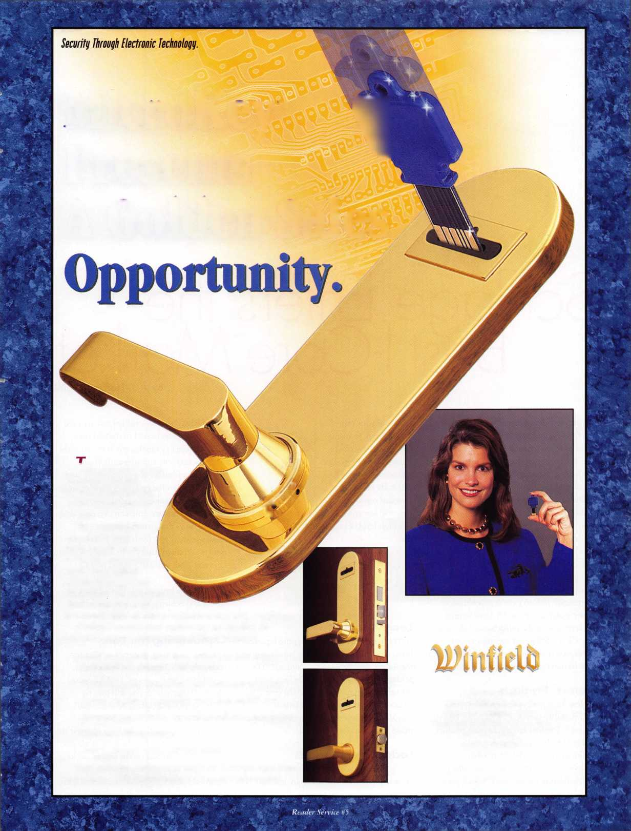

Schlaae Enters the , Best 1-Core Ma rket

**By AJ. Hoffman, CML**

The latest development in patented key control is the market debut by Schlage of a broad selection of small format interchange­able core (SFIC) products. The small format core has been commonly referred to in the past as the “Best Style interchangeable core.”

The first interchangeable core was created by Best Lock around 1920. Over the years many Best-core clones have appeared in the market, designed to accommodate the SFIC locksets. But, until recently, very little attempt has been made to design patented key control for the numerous buildings already equipped with this hardware. This is a significant industry niche given that property owners frequently have security problems due to the unauthorized duplica­tion of keys. Schlage is the most recent manufacturer to supply patented key control systems to retrofit existing SFIC hardware.

**Everest™ Products**

New Schlage keys and cylinders protected by U.S. utility patent 5,715,717 are called Everest”. The first Everest keyway product produced is the small format core.

The patented undercut groove requires a secondary milling operation to make the key blank. It is a violation of federal patent

A Keynotes December 1998

law for anyone other  
than Schlage to manu-  
facture and distribute  
these blanks. Protection  
extends into the year  
2015. By replacing  
standard cores with

patented key cores, end users can be assured  
of a high level of key control.

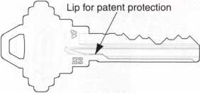

**Long Patent Life**

Whenever key control is required, patent life is important. The later the patent expires, the longer the key system should last. The Schlage Everest patent protects keys from unauthorized duplication into the year 2015. That’s five years longer than Medeco Key Mark and seven years longer than Kaba Peaks (also marketed by Best).

**Locksmith Programs**

The first keyways being introduced are for large key systems maintained by institutional

locksmiths. The restricted keyway selected for each job is registered to the end user.

Restricted key blanks, cut keys and cores are furnished only through authorized Schlage distributors or service centers, and then only when the end user’s letter of autho­rization accompanies the purchase order. Restricted items are drop shipped directly to the end user’s designated location. This creates positive key control by preventing dealers and distributors from having access to keys and cores without the end user’s permission.

A separate keyway will be sold through authorized Schlage service centers for end users who do not have in-house locksmiths.

**Combinating the Core**

If you are already familiar with combi­nating Arrow, Best, Falcon, Kaba Peaks, KeyMark or KSP cores to the A2 System (depths 0 through 9), you will find no difference in combinating Schlage small format cores.

In Everest cores, the blocking pin near the front and to the right of the keyway checks for the lip of material on the side of the key.

This pin does not participate in the combination of the key and it remains safely

i

Patented

Undercut

Groove

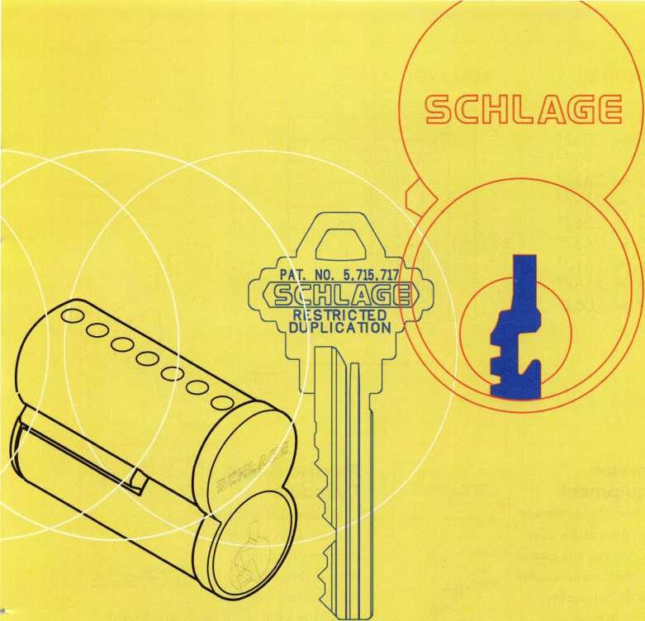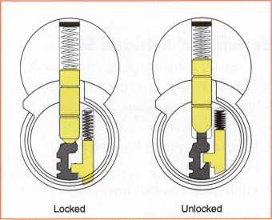

inside the core during the combinating process.

Like other brands of these small format cores, the Schlage core should never be dismantled for combinating or decombi- nating.

If you already own a different brand of specialized pin kit and tools for Best style cores, you may use them for Schlage cores with the following exceptions and cautions:

1. Do not use Arrow bottom pins because the bottom flat is smaller and may not seat properly on a zero cut when next to a 9.
2. Do not use Kaba Peaks bottom pins, as they are .003" too short for Schlage cores.
3. For security reasons Schlage advises against using colored bottom pins. The colors can be read through the keyway with a lock

scope, revealing the combination. They are also less resistant to wear than nickel silver bottom pins.

1. Only the original Schlage 40-104 pin kit contains the plug retainer and the blocking pin and its spring. These components normally do not need replacement but the supply may come in handy to repair an occasional vandalized or worn core.
2. Due to the location of the blocking pin, the ejector holes in the bottom of Schlage cores are all shifted by .010" toward the back of the core. This may cause problems in certain core decombinating fixtures and presses. Using any brand of ejector pin one chamber at a time, however, should pose no problems.

Schlage reserves the right to void the warranty if the core is combinated with components that do not conform to our spec­ifications, or if keys are not properly cut.

**Cutting Keys**

Schlage keys use a shoulder stop against the plug face. Most other brands of SFIC keys stop at the tip. Punch type machines for other Best style keys will not work for Everest keys and vice-versa.

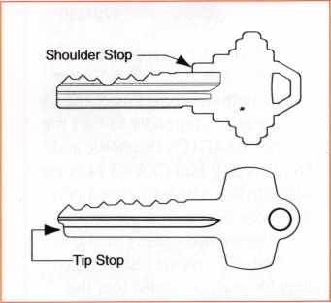

Schlage sells a  
special version of  
the Blue Punch  
key machine for  
Everest keys.

To cut Everest

keys on rotary cutter code machines it may  
be necessary to modify or replace the vise  
jaws. Contact your key machine manufac-  
turer directly.

Since the Schlage Everest core is designed  
to replace cores by Best, Arrow and others,  
Schlage’s key cuts are read and written TIP  
to BOW. This is the opposite of other  
Schlage keys but standard in the small  
format IC world.

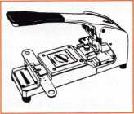

December 1998

***Keynotes*** I

**STRATTEC TECH**

Q

IF a HI TECH SECURITY  
SYSTEM IS INTEGRATED  
WITH THE VEHICLE S  
COMPUTER, DOES

THAT MEAN ONLY  
THE DEALERSHIP CAN  
SERVICE IT?



DEFINITELY NOT!

WITH THE PROPER TOOLS,  
THOSE PROFITS CAN GO  
TO AN INDEPENDENT  
LOCKSMITH LIKE YOU.

#704630

Chrysler vehicles equipped with the Sentry Key Immobilizer System require both the correct mechanically cut key and transponder to start the vehicle. STRATTEC's Diagnostic and Programming Tool (D.A.R.T.) lets you program the vehicle to accept new key codes (up to eight per vehicle). Pre-programmed codes can also be deleted if keys are lost or stolen. Built for years of rugged use, the D.A.R.T. is simple to use, with an easy-to-read LCD display and multiple- function keypad to move quickly through operational menus. This new system includes everything you need to handle the Chrysler S.K.I.M. — it's your key to the next generation of vehicle security.



**STRATTEC**

For more information, please  
call your STRATTEC authorized  
wholesale lock distributor

Reader Service#6

December 1998

DEPTHS: SPACING:

1. = .3187"
2. = .3062"
3. = .2937"
4. = .2812"
5. = .2687"
6. = .2562"
7. = .2437"
8. = .2312"
9. = .2187"
10. = .2062"

1

**1**.096"

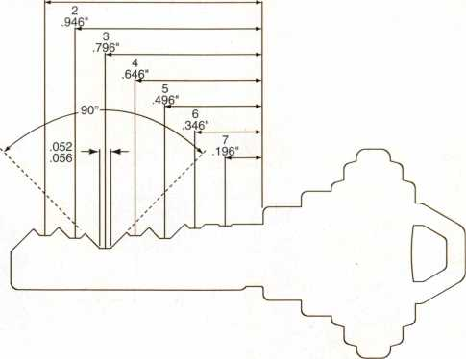

**Service  
Equipment**

Note: If you already  
own comparable Best  
style service equipment  
by other manufacturers  
you do not need to  
invest in new  
equipment other than  
the key machine for  
Schlage Everest cores.

**Everest" to  
Expand**

In 1999 Schlage will introduce different families of Everest keyways for the standard full-size cylinder including Primus, and add Everest SFIC keyways for the commercial locksmith.

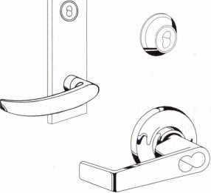

**Locksets**

An array of Schlage Grade 1 and 2 deadlocks, mortise locks and key-in-lever locksets are now available to accept these cores, as well as other brands of small format cores.

**Mortise & Rim  
Cylinders**

Schlage SFIC mortise  
cylinders offer greater  
inventory flexibility  
because their cams are  
the same as those used

on Schlage’s full size IC mortise cylinder.  
They are easily changed with a screwdriver,  
as opposed to other brands whose cams are  
staked or riveted on.

**Benefits of Schlage SFIC**

If you are currently using other brands of SFIC locks and cores, the benefits of Schlage s product offering deserve your serious consideration:

* Long utility patent life protects keys until 2015;
* High quality lockset line;
* Competitive prices;
* Wide choice of competitive distributors;
* No additional training needed;
* Compatibility with most existing service equipment;
* Inventory flexibility with mortise cylinders and locks.

For further information, consult your local Schlage distributor or Schlage Customer Service at (800) 847-1864 or fax (800) 452-0663.

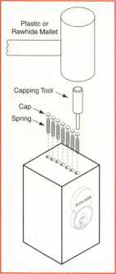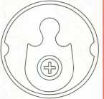

Keynotes

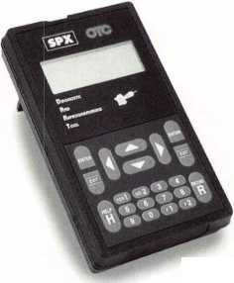

by Tim McMullen

In recent issues of Keynotes magazine, we’ve seen a resurgence regarding the licensing issue (September’s “Point-Counterpoint” and October’s “Letters to the Editor”). This is a good thing. Locksmiths should continu­ally be discussing this issue, because only through well-formed ideas can we educate our members on the realities of the issue. That is why articles from Sal Dulcamara, CML and Kathy Zaniolo, CPL are so important.

For the last year, I have worked on licensing issues for ALOA whether it was helping to get a bill passed, or helping to defeat one. The first reality is that no two states are alike. What works in New Jersey would be a hard sell in Texas. Illinois has a locksmith licensing law and so does Nevada. They are about as different as any two laws could be. The bottom line is, there’s no one answer to licensing, and ALOA takes its cue from its members. ALOA’s Board of Directors passed a resolution that calls on the organization to become more proactive in state licensing and regulation of the locksmith industry. However, we would only promote legislation that a fair number of our members in that state were behind.

The second reality is that there will always be groups we feel should be included in a licensing law, who eventually will be left out. These include hardware store personnel, police officers and tow-truck operators. Every law on the books exempts these groups in one way or another, because they lobby hard to be exempted. The truth is that none of these bills would survive unless they were exempted. However, those exemptions are narrowly drawn. Most of them allow hardware store personnel to only cut keys. Police can only open cars or homes in emergency situations. Tow- trucks can only open cars as part of their duties as a tow-truck operator. There are situations, however, that these groups cross those boundaries. We’ve gotten many calls about tow-truck operators or police opening cars when they shouldn’t. This call usually contains the phrase, “I don’t know why we have to be licensed if they don’t have to be.” Well, they have to be if they are doing locksmith work. But the sad reality is that people try to get around laws all the time. That’s why it is so important for members to call us to report violations or call their state licensing agency.

The third reality is that regulations are sometimes interpreted and enforced differently than what the law intended. For instance, ALOA fought hard to get one regulatory agency to interpret “emergency situation” as being life-threatening. Currently, they interpret it to mean any time you are locked out of your car or home! The best way to make sure a law is interpreted the way you feel it should, is to make sure you are sitting on that regulatory body. We have a number of members who serve on their state’s licensing board, and through them our interests are served. ALOA is also making inroads with the National Association of Security and Investigative Regulators (NASIR) to have laws interpreted in our favor. Unless you’re making the rules, sooner or later the game isn’t going to go your way.

There are also situations where there isn’t even a law on the books regarding locksmiths or alarm technicians, and we still are regulated!

One state recently decided that locksmiths should be regulated under their Home Improvement Act. Now, locksmiths pay a fee for nothing in return! State governments are starting to see us as a skilled profession, and are requiring some accountability.

The reality is that locksmithing is a skilled profession. Not everyone can

open a car with electric locks and not cut the circuitry (look how many times locksmiths have to follow a police officer’s “mistake”). Certainly, not everyone can master key a home or commercial building. Not everyone can install a Detex alarm. The profession requires training and experience.

The public should (and some of it does) realize that locksmithing is a specialized profession. To the general public, licensing demonstrates that you have met certain qualifications through testing or certification and have the “stamp of approval” by the government. For whatever reason, the public does believe that license equals skilled professional.

The licensing issue will always be a hot topic of discussion. But it’s important that it is always discussed and dealt with in well thought out arguments. There are no right or wrong answers, just what makes the most sense under the current circumstances.

LEGISLATIVE CARRY-OVER

NOTE: New Jersey and New York have state legislatures that run year-round.

NEW JERSEY A2104/Si059 Exempts from the new locksmith law: sales reps offering demonstrations, automotive service dealers, trade unionists and any person using a key duplicating machine.

NEW YORK Al 1425 Requires locksmiths to obtain identification from a person requesting the performance of an opening of residential or commercial premises, safes, vaults, and motor vehicles and to keep records and to provide access to records by law enforcement officers.

NEW YORK A3974 Permits a state income tax deduction for home security devices (including locks) installed by the owner occupant of a one, two or three family home for an amount not to exceed five hundred dollars.

NEW YORK A489 Grants an income tax credit for certain private security devices in a dwelling unit.

NEW YORK A5315 Establishes security requirements to be fulfilled by owners of multiple dwelling units including deadbolt locks, window pins, adequate lighting, solid core door and optical viewers.

N EW YORK A8590/S4880 Provides for a possible tax credit in cities of one million or more for security improvement measures or enhancements made in class 2 dwellings; authorizes a one-time credit of up to 20% of the cost of such measures or enhancements; includes, but is not limited to, the employment of security guards, and the installation of enhanced lighting, monitors, locks, fences or other improvements designed to enhance security.

NEW YORK S2130 Requires intercommunication systems and automatic self-closing and self-locking doors in class A multiple dwellings with eight or more apartments.

RHODE ISLAND HB7376/SB2303 Relates to the licensing and regulation of locksmiths. Based on ALOA Model Law. Tabled in Labor Committee

RHODE ISLAND HB8660 Deletes current Burglar and Hold-Up alarm Business statute, and places all regulation and rule-making in the hands of the director of the department of business regulations. Transferred to House Committee on Finance.

19

December 1998

Keynotes

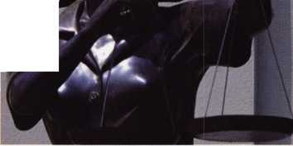

my people still think of intercoms as

little more than convenient room-to-room  
communication tools. Intercoms are now  
much more than that. They are fast  
becoming the core of sophisticated audio/  
visual security systems used by commercial,  
industrial and residential customers.

Businesses are changing how they use intercoms. Hotels are not only monitoring their building entrances, but installing video entry systems at the doors of their executive suites. Fast-food restaurants are stationing video door cameras at employee entrances. A video entry system is far better than a buzzer in that it shows you who is at the back entrance. Hospitals are also using video entry systems as part of their security systems for surveillance of drug rooms and back offices in addition to monitoring entrances.

Commercial customers are not the only ones buying video these days. The demand for security in the residential market has increased significantly in the last few years.

People are more security conscious, both when they’re away and at home. Whether it’s the luxury home, moderate home, or an apartment, an intercom system can provide homeowners “presence protection.”

An audio/video intercom system can serve as the eyes and ears of a home, augmenting perimeter alarm systems. Outside sensors pick up noise or movement and activate intercoms or monitors, alerting occupants to unusual outside activities before someone breaks a window or kicks in a door. Video images can even be piped to home televisions if coaxial cable is installed. Plus, video systems are less expensive than they used to be, and are easy to install, even in retrofit situations.

If a video system doesn’t fit a budget or application, a simple intercom system may. Like the video system, two-way audio intercoms can often be installed simply by using an existing doorbell wire, which is very inexpensive. Audio intercoms provide

communication room-to-room, room-to- door, and many have a simultaneous all call that allows the homeowner or business to communicate with all room stations at once.

Intercom systems are unobtrusive and don’t look like security. The audio/video intercom systems can be installed to enhance any household or office decor. Door stations at outside entrances blend to the building, are small and compact. Room stations seem more like a convenience than anything else.

The list of intercom system applications is extensive, and continues to grow. Systems have been installed in such unique places as nursing homes, casino pits and money rooms, ski lifts, luxury box entrances, trains, elevators, bowling alleys, fishing boats, limousines, drug stores, and drive-through banking. Every commercial, industrial or residential customer needs some sort of communication system. An intercom system provides just that; communication plus security.



Keynotes

December 1998

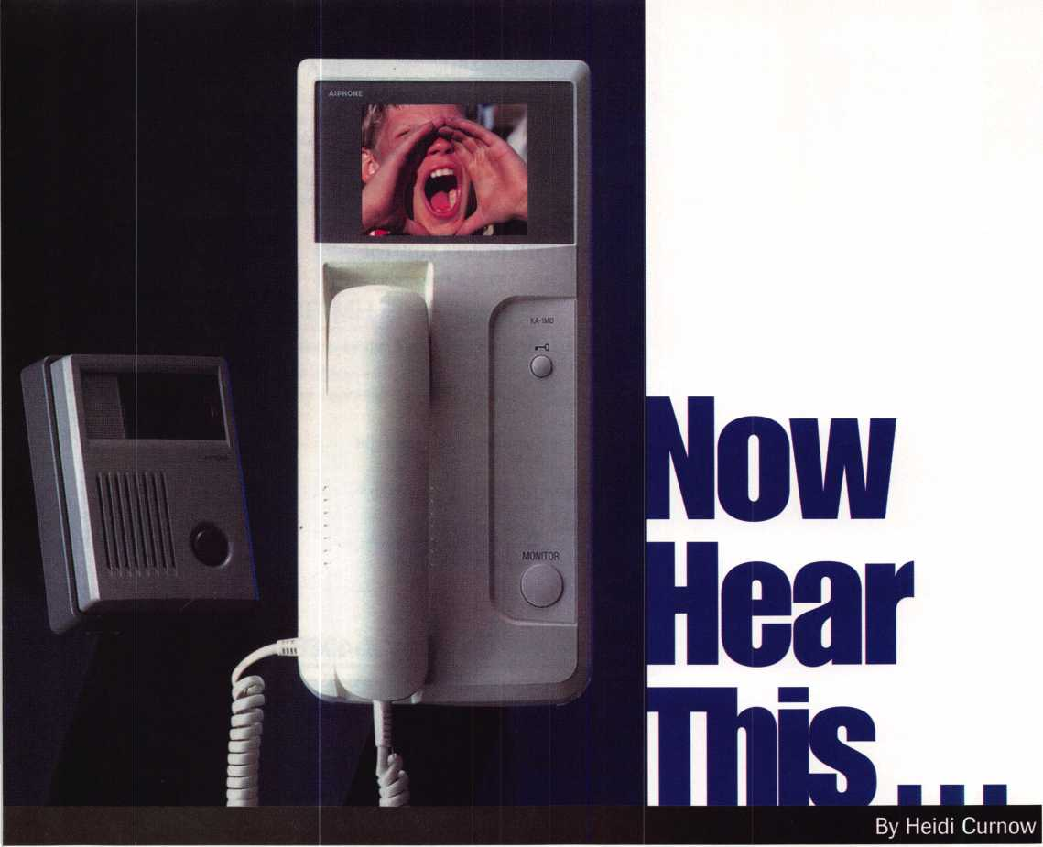

GET IN TOUCH IITH YOUR ASSOCIATION

**What’s going on at [www.atoa.org](http://www.atoa.org)?  
Oh, not much, just...**



Urgent News

Legislative Bulletins

Upcoming Events

Industry Happenings

About Keynotes Magazine

Members’ Bulletin Board

Frequently Asked Membership Questions

ALOA’s Convention and Security Expo

The ALOA Store

Continuing Your Locksmith Education Becoming ALOA Certified Web Classifieds

ALOA’s Members in Mfg. and Distribution Industry Links Member Links

“Quick Contact” links to the ALOA staff

**Information for the public about you, the professional locksmith, including:**

**For those interested in becoming a professional locksmith, we offer:**

**And, of course, there’s stuff just for you like**

**And we’re planning even more for 1999, so stay tuned.**

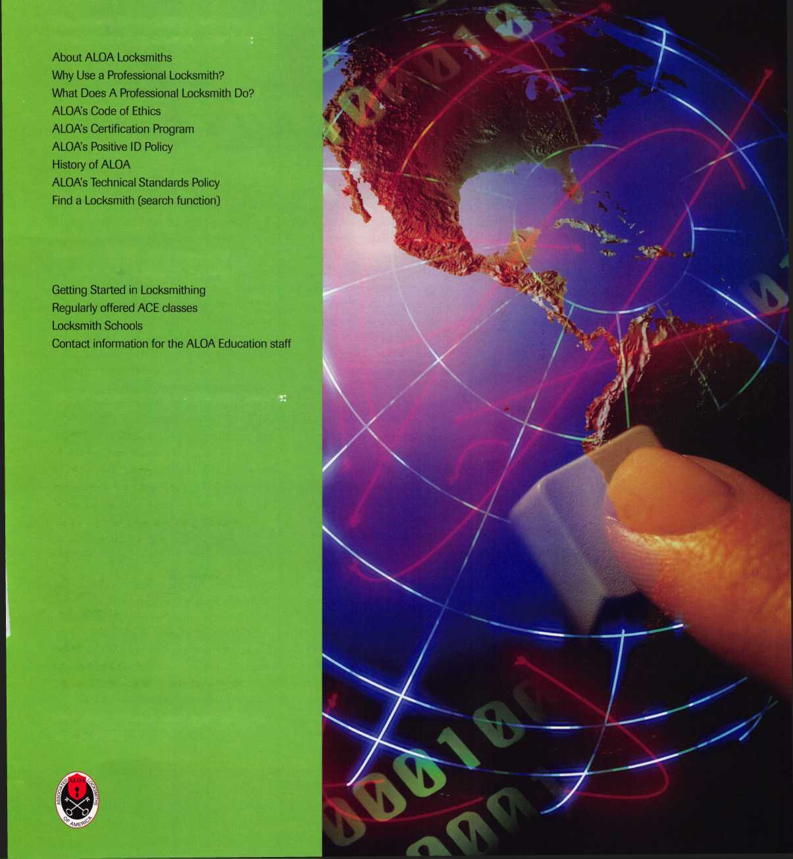

While hardware designers look towards the  
future in terms of technical inspiration, it

seems that many consumers would

prefer to take a trip back in time.

Modern door hardware has  
obviously become more sturdy in  
structure, but sometimes its  
visual appearance does not  
always meet the needs or tastes  
of homeowners, interior  
designers or even art directors.

With the advent of home restora-  
tion and people’s interests reverting

to the styles of yesteryear, the demand

for materials that contain both modern  
convenience and a historical semblance is at  
an all time high.

Enter Nostalgic Warehouse, a Texas-based  
company specializing in the reproduction of  
antique doorsets with the necessary adjust-  
ments made to fit on contemporary doors as  
well as on older ones.

The company, located in Garland just  
adjacent to Dallas, has been in business for  
16 years and is the brainchild of president  
Andrea Ridout.

Since her childhood, Ridout has had a  
keen fascination with antique doorware.

Born in Ohio and raised in Indiana, Ridout  
remembers her family restoring a Victorian  
house, which sparked her fondness for old  
fashioned doorplates and locks.

“At that time, the knowledge that people  
had about restoring older houses was

minimal,” she says. “I’m sure we made a lot of mistakes on that house, but it came out really pretty in the end. It was during this job that I got really into old houses, and fortunately, my interests carried through into my adult years.”

Originally she was the driving force behind an antique business named Creations Unlimited where she sold and restored antiques. In the restoration of different articles, she had accumulated an inventory of decorative hardware that would just sit around going unused. With that, she began selling the left over hardware to other antique dealers and a new business was born. She soon put out a mail order catalog and says that within five years, she had amassed 8,000 to 10,000 dealers nationwide as clients.

“Nobody was making restoration hardware that could actually be used in new construction,” says Ridout. “Builders were responsive to the products and wanted to see new patterns. In using the older patterns, we would make adjustments like widening the plates and changing the hubs. We standard­ized everything, so that any of these doorknobs could work on any of the different plates. At that time, we were dealers for different hardware brands like Kwikset, Schlage, Baldwin and numerous others. Within a year, we were selling our own brand of hardware at a competitive rate with the larger companies.”

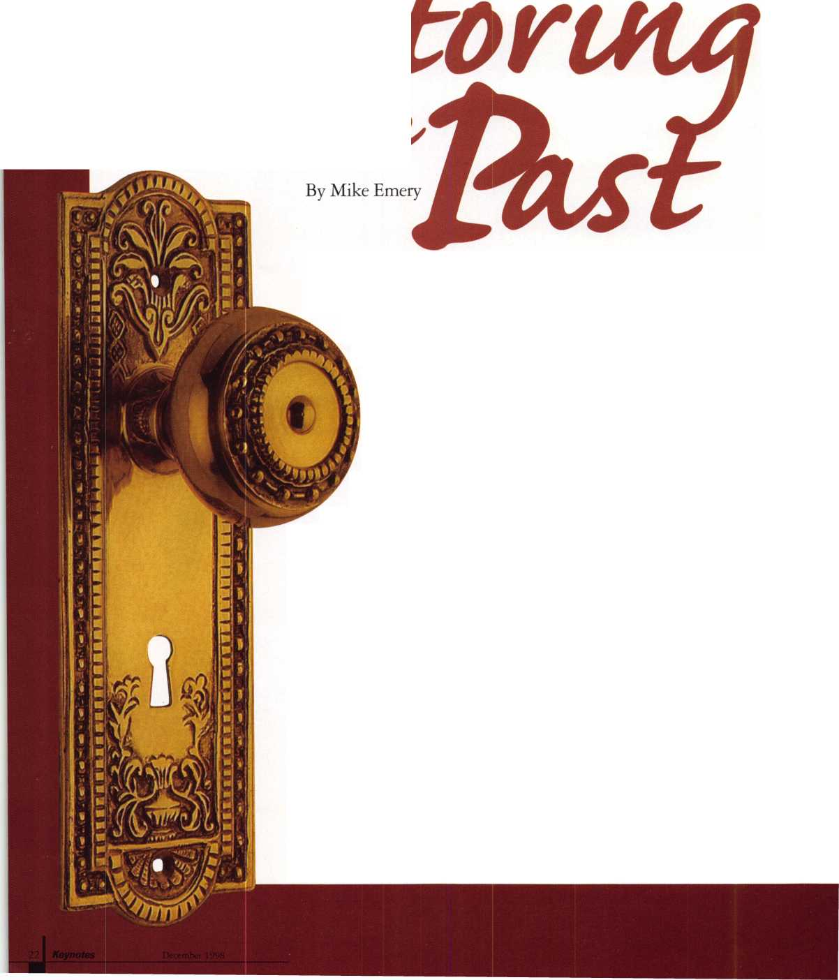

With the retail focus being shifted towards hardware, the outfit was renamed Hardware Plus in 1989, then Nostalgic Warehouse in 1997.

Soon, Ridout’s efforts paid off as Nostalgic Warehouse began to accumulate more and more commercial work. Spaghetti Warehouse and numerous other restaurants were utilizing products from the outlet. Soon other ‘theme’ oriented businesses like Disneyland, Disneyworld, and Euro- Disneyland began seeking accessories that looked as if they were constmcted during another period.

“When Nostalgic Warehouse was getting off the ground, we further developed our products,” says Ridout. “Generally, commercial work is a lot more demanding than residential work. That’s one of the reasons we added a second set screw on all of the knobs, so that we could get the two set screws going in at a 90 degree angle to make it tighter.

“The MGM Theme Park in Las Vegas was one of our earliest clients. We didn’t do the behind the scenes hardware. We did all the decorative set hardware. If you go there, take a look at the pirate ship. The doors on the ship use our hardware as well as the various restaurants within the park.”

Aside from providing hardware to parks, restaurants and casinos, it wasn’t long before Nostalgic Warehouse began making its mark within films. Among the numerous movies that have Nostalgic Warehouse products as part of the set are The Horse Whisperer, Doctor Dolittle (1998 version), Small Soldiers, Ace Ventura II, and The Firm.

Television projects that have used Nostalgic Warehouse’s goods are Wishbone, Walker: Texas Ranger, and Sabrina, the Teenage Witch.

“We tend to do films that are not filmed in Los Angeles,” says Ridout. “That’s why we’ve done a lot of White House oriented films like Air Force One,

My Fellow Americans, and Murder at  
1600. Those films were all shot in  
Washington DC. When a movie is made  
in LA, say on the sound stage at Warner  
Brothers, there’s already a hardware  
department and a wealth of items for an  
art director to work with. But when a  
movie is made elsewhere, the art director  
doesn’t have time to develop outside  
resources. That’s where we step in.”

When the film, Legends of the Fall was  
being filmed in Canada, specialty  
hardware sources were sparse, so  
Nostalgic Warehouse was called to  
provide the necessary items. Likewise,  
when Ace Ventura II was filmed in Africa,  
Ridout’s company came to the rescue  
when hardware proved to be difficult to  
find.

“Most people watching a movie

would never think about what this

kind of stuff looks like or what period

its from,” she says. “I notice it a lot.

For instance, in Titanic, which we did  
not do, there were minor errors in the  
hardware. We could tell that some of  
the hardware was not entirely correct  
for certain sets.”

Of all the films that Nostalgic Warehouse has contributed to, the Robin Williams comedy-adventure,Jumanji has the most evident examples of Ridout’s handiwork. With its close-up shots of hardware to show how its once shiny brass exterior has aged to a vintage patina.

“This movie could almost be a commercial for Nostalgic Warehouse,” she says. “They didn’t spend that much on hardware as opposed to other films, but in every scene, you can see our hardware.”

Things are certainly looking bright for Ridout and Nostalgic Warehouse. As long as they can preserve the look of the past, more and more clients seem to be in their future. Still, Ridout feels that there are still enhancements to be made on their products. With that, customer feedback is an essential element in

making the necessary modifications and  
ensuring long term success.

“We’re working on bringing out some  
new patterns and also making our  
products easier to install,” she says.  
“We’re constantly improving it from its  
original antique design and our  
customers give us feedback on changing  
little things. You know, like switching to  
Phillips-head screws. As we have

marketed the product, we’ve  
received more and

more responses,  
which allows  
us to keep  
making it better.”

Anyone  
interested in  
learning more  
about Nostalgic  
Warehouse’s line  
of products can  
contact the  
company at:

701 Kingsley Road  
Garland, TX 75041  
(800) 522-7336, or  
www. nostalgicware  
house.com

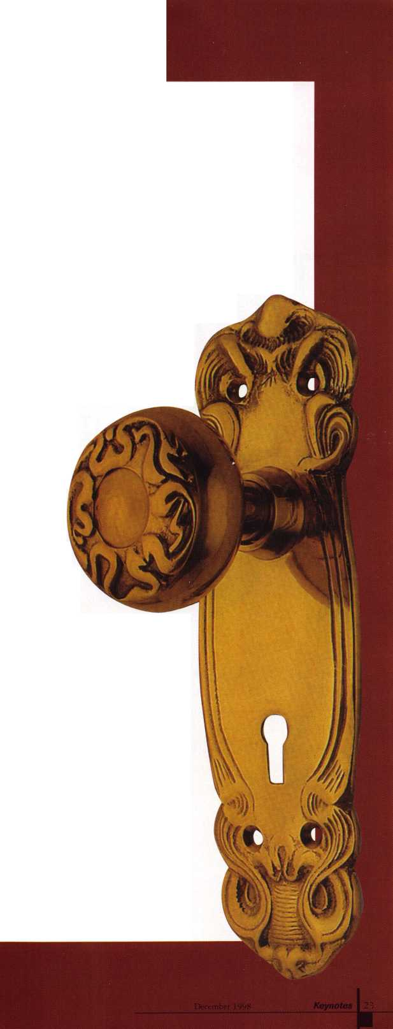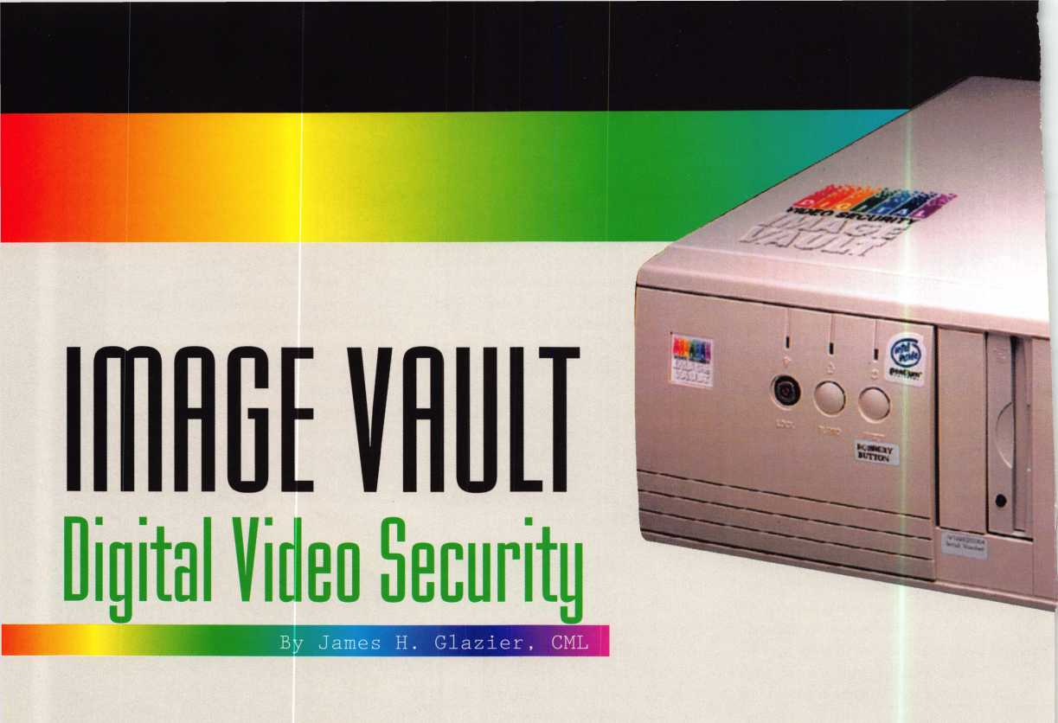

Image Vault, LLC of New Albany, Ind. has brought to the industry a complete line of digital video recorders. These are the first affordable plug and play replacements for analog tape recorders. They have four models available, two with four camera inputs in 72 or 144 hour storage at one frame per second and two with eight camera inputs in 72 or 144 hour storage,

Each model has a Pentium MMX Processor, one monitor output,

4 gb or 8 gb hard drives, a 33.6K Modem, an Iomega internal “IDG” 100 mb Zip Drive and four alarm inputs. These units come with a software package that provides 72 to 144 hour storage at one frame per second, the ability to record up to four frames per second- utilizing either color or B&W cameras—and allows for “on the fly” detection of cameras at installation.

With this software package you can “dial up” a remote site with the modem on your computer, then browse and download images remotely. I found the quality of the digital images that were received of excellent quality and easily identifiable. Once connected with the remote site, you are presented with a screen where you may choose any one of four or eight cameras (depending on the model), view the scene you have chosen “live” or you may request a specific previous time frame to view. While viewing, you can elect to download this date to your remote computer for later viewing.

With the Iomega internal “IDE” 100 mb Zip Drive you are able to save data for future reference either on site, on a remote computer

.1 Keynotes December 1998

or on zip cartridges. The greatest advantage to this type of recorder is the ease with which you may access the data both remotely and on site, store the data for future reference, and manage the data remotely. The amount of data that is stored is more than adequate for all video surveillance purposes. When the maximum number of frames is achieved, the oldest frame is dropped from the hard drive and the newest frame is added so you have a constant 72 or 144 hour record of activity on four or eight cameras.

The provided software appears to be excellent and allows easy “Catalog” look-up-all images available at “all” times, date and time recording with every image, saving of images individually in a BMP format, and printing. It allows recording up to 40 seconds before an alarm event and control of when to store on the hard drive. You may save images to the removable zip disk for off-site viewing or as evidence. There is multi-level password protection and you may edit parameters on-site or remotely.

The “Image Vault” provides an excellent audit trail for security tracking with constant image quality. No external multiplexer is needed and all equipment is Year 2000 compliant. The complete unit is 17" deep, 16 3/4" wide, 6" high and weighs in at 35 lbs., about the size and weight of a standard desk model CPU. Units come with all necessary cables and an operations manual.

The only caution that I have with digital equipment is that at the present time it is unsure if the Courts will accept digital images as

evidence in criminal and civil cases. This is due to the fact that these images can be “enhanced” within the computer, and therefore can be changed or improved from the original. Much depends on the ability of the operator to testify that the image presented in court is a true representation of the actual scene at the time of the incident, and the court acceptance of this testimony. I am sure as more and more similar equipment appears on the market, these will be accepted by the courts as they will provide an excellent evidence of what has actually occurred at a particular scene at a given time and date.

Overall, this product appears to have an excellent future with a price that is readily affordable to the end user. The cost is little more than a quality VCR and Multiplexer, yet allows for off-site or remote viewing and management of data. In order to utilize this equipment to the fullest extent, one must have a minimum 486/66 mhz computer, 1 mb of Video Ram (preferable 2 mb), 3.5"

Diskette Drive, a Modem and a 9-pin serial port.

For complete details on this product you can contact Robert Veenstra, national sales manager, Image Vault LLC, 101 Security Parkway, New Albany, IN 47150-0559. He may be contacted by phone at (888) 462-4382; Fax at (812) 948-0437; or email at [bveenstra@image-vault.com](mailto:bveenstra@image-vault.com).

INTERCHANGEABLE  
COREPRODUCTS

Interchangeable

with:

•BEST • ARROW •FALCON >

Quality • Price Delivery

That's what KSP is all about!

KILLEEN SECURITY  
PRODUCTS

Ask your wholesaler about  
our drop shipping**.**

***33 Hermon St.  
Worcester, IMA 01610  
Phone (508) 798-3200  
Fax (508) 753-2183***

Reader Service#7

ALOA  
NOW HAS  
FAXON

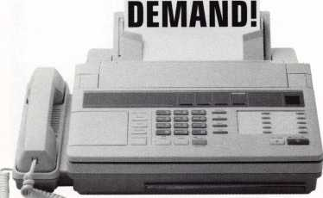

Need information in a hurry?

Just call 310.575.5074 and you uuill be faxed:

#1 A list of all documents available through this service #2 Becoming A Locksmith #3 Locksmith Career Summary #4 Locksmith School List #5 ACE Class Schedule #6 Certification Information #7 PRP Category List #8 ALOA Membership Application #9 ALOA List of Benefits

#10 Scholarship Application Form #11 ALOA Video Library Order Form #12 ALOA Membership Items Order Form #13 Safe & Vault Technicians Association Member Application/Subscription Form #14 ALOA Chapter Roster #15 Legislative Action Network #16 Legislative Action Network Newsletters #17 Various State Laws #18 Industry Position Paper

Your association continues to explore ways to provide you,  
our members, with new benefits and services.

December 1998

Keynotes

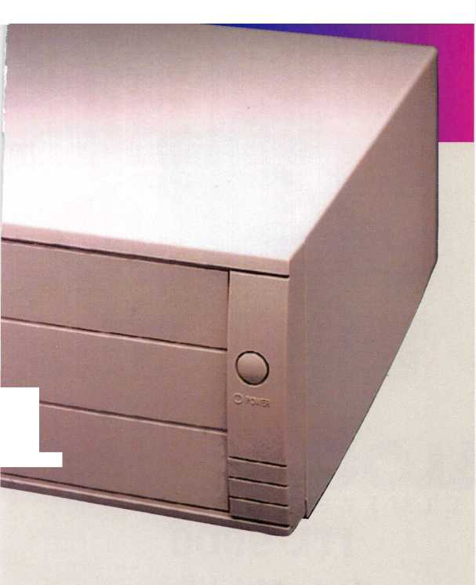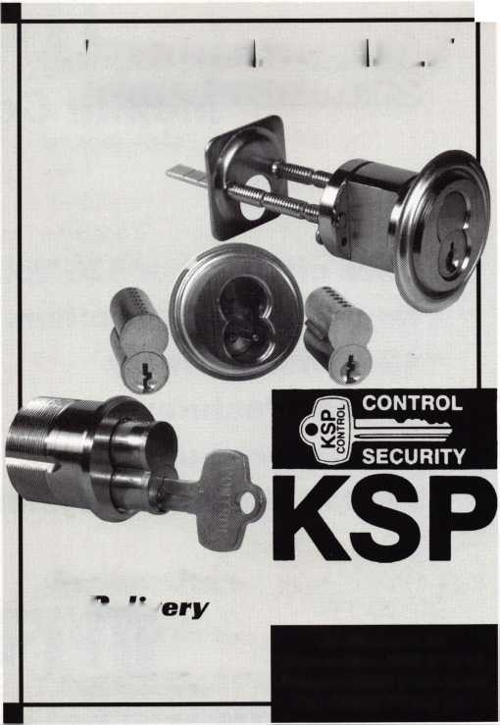

ITL 950

Mobile Code Machine

* Uses either 12 or 120 Volts
* Heavy duty construction.  
  *12 Month warranty.
* All manufacturer depths  
  and spaces built in.
* Built in Master Key system.

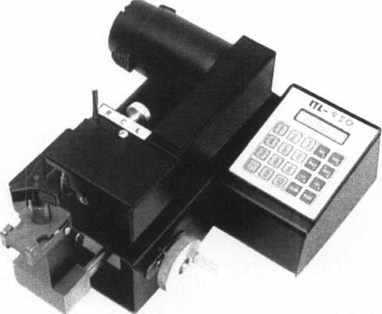

IfTRALOCC

TOOLS

* NEW* INDUSTRIAL.  
ITL 9700  
CODE MACHINE

**LIMITED**

ITL 9000

Code Machine

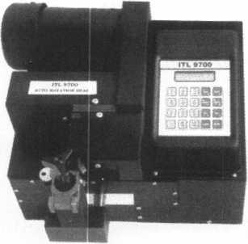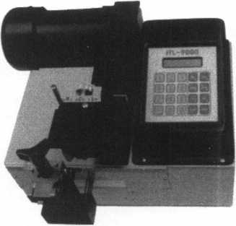

New MEDECO

Autoswing head Option *Dependable, heavy-duty construction, one-year

Cuts 6 pin Biaxial In 17 seconds parts and labor warranty.

* Super bearing construction *Serial port to connect to Reed, Treskat, Blackhawk

*Ball screw drive and other second-source code systems.

*Superior Rigidity and Accuracy *Repeatable accuracy of 1/1,000th inch. *Shipped with carbide cutter *Cuts Medeco High Security keys.

*2 year parts and labor warranty *Up to 800 built-in manufacturer depths & spaces.

— Now Distributed Throughout USA, Canada & Australia —

2639B Progressive Way • Abbotsford, BC Canada V2T6H8  
USA: 310-699-0060 • Canada: 504-352-8904 • Canada Fax: 504-352-5938 • Toll Free: 1-588-264-6627

Reader Service #8

**Is there a**

I have spoken to many locksmiths who  
are interested in expanding their business by  
offering closed-circuit television systems.  
They are aware that CCTV is a two-billion  
dollar a year business, the fastest growing  
segment of the security market. In many  
cases they are already installing electronic  
locking systems and access control, and they  
see surveillance as a natural companion  
product. The question is, how do I get  
started?

Becoming a CCTV dealer involves more  
than learning a new technology. You also  
need to understand the new competitive  
marketplace you will be entering. Who are  
the players? How do you establish prices?  
What can you do to stand out from the  
crowd?

At one end of the spectrum you will be competing with electronic security dealers, some of whom are primarily in the burglar alarm business and others who specialize in “systems” (CCTV, access control, electronic

article surveillance, etc.). At the other extreme you have the do-it-yourselfers. A number of retail outlets now offer simple CCTV equipment that is very inexpensive and that almost anyone can install. The

December 1998 Keynotes 27

competition for any given CCTV project will depend to a great degree on how large and how technologically sophisticated the system must be.

Is the project a “small” system or a “large” one? Small systems are one to four cameras. More than four cameras should be considered a large system. I say this because you can manage the input from one to four cameras effectively with sequential switchers or quads. Switchers display each camera in turn on the monitor, alternating from camera to camera every few seconds. A quad is a signal processor that allows you to display all four cameras on a split screen at the same time.

As a general rule of thumb, when you have five or more cameras you should manage the signals with a multiplexer. Multiplexers are relatively expensive pieces of equipment that allow much greater flexibility in recording and displaying video signals.

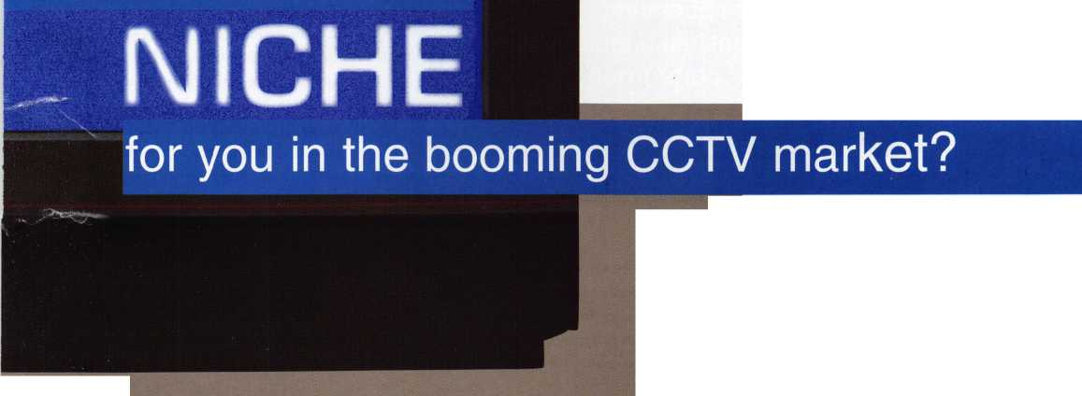

If you are dealing with a small system,  
you would do well to consider a quality  
“plug-and-play” observation system. Similar  
to the D-I-Y equipment at Sam’s Club and  
elsewhere, these systems do not cost a lot and  
they are very easy to install. Some systems  
have a sequential switcher built into the  
monitor while somewhat more expensive  
systems feature an integral quad. Observa-  
tion systems are available for both black &  
white and color. How do you compete with  
the D-I-Y products for small system sales?  
You do this by providing the specific features  
that exactly meet your customer’s needs.  
Boxed systems take a “one-size-fits-all”  
approach. As security professionals, we  
recognize that every situation is different.  
Many people go out and buy D-I-Y

surveillance equipment that doesn’t  
come close to meeting their real  
needs. This is like investing in  
pick-resistant cylinders for your  
grade 2 cylindrical locks when the  
real problem is door kick-ins. Pick-  
resistant cylinders are great for one  
security problem but useless in  
coping with others. Likewise, you  
need to match the CCTV system to  
the real security issues at hand. One  
manufacturer of quality observation  
systems, which have a variety of  
versatile features, is the Philips  
Corporation. Philips is a 100 year-  
old international company that  
pioneered the concept of “Observa-  
tion systems.”

Philips offers four systems: a  
black & white switcher system

(VS23605T); a black and white quad system  
(VS23645T); a color switcher system  
(VS73705T) and a color quad (VS73745T).  
Each system comes with a single camera and  
you may add up to three more cameras. A  
camera mounting bracket and 75 feet of  
cable is included with each camera. The  
camera that comes in the original kit has a 4  
mm wide angle lens. The additional cameras  
you order may be fitted with 4 mm or 8 mm  
(normal) lenses.

A single cable is connected from the back  
of the monitor unit to each camera. This  
four-wire twisted pair cable has standard  
RJ11 jacks at each end (just like your  
telephone). You can locate each camera as far  
as 900 feet away from the monitor without a  
signal booster (1800 feet if you add a video  
amplifier). This single wire carries power to

the camera, video to the monitor and audio in both directions. It also conveys alarm signals and command signals that relate to unique system features.

What are some of the features of this equipment that allow you to customize each system? Most D-I-Y systems have fixed (non-changeable) lenses. Philips uses industry-standard “CS” lenses. This means that you can unscrew the lens that comes with the camera and replace it with a commonly available one, which might better fit your needs. If you need a very wide angle lens you might add a 2.8 mm. If your subject area is very far away, a telephoto lens of 12 mm or even longer might be used. For indoor surveillance 4 mm and 8 mm lenses

are certainly the most common, but it is nice to have other options. Many cheap kit cameras have a high “lux” rating (2.0 or higher). This means the camera needs quite a bit of light to make a usable picture. Philips black and white cameras have a very low 0.1 lux rating, making them suitable for very low-light situations. Even the color cameras are pretty good, at 0.9 lux. While a low lux rating is unimportant when you have a brightly lit scene, it is crucial when the available light is sometimes quite low.

Alarm inputs on the camera allow the addition of door contacts, PIR motion detectors or other sensors. When an alarm is triggered at a camera location, the monitor chimes to get your attention and that camera is displayed full-screen. A video recorder might also be triggered to begin recording

when an alarm is registered. In fact, the new VS23645T black and white quad system has a nifty feature called “Event Replay” that digitally stores and replays a triggered event including four seconds of video before and after activation. The use of alarm inputs greatly increases the usefulness of a system that may or may not be constantly monitored and is especially useful when recording. Philips offers four “boxes,” acces­sories that add even more features to their systems. The intercom box allows two-way communication between the monitor and the camera location. Even without this box you can hear audio at the monitor from the camera’s built-in microphone. The intercom box improves audio pickup and also allows you to speak to people near the camera by pressing the “talk” button on the monitor. Many businesses would like to have an audio and video intercom system to screen visitors. The intercom box addresses that need.

The action box activates a set of dry contacts when you push the “Action” button on the monitor. These contacts could be used to activate an electric strike, set off a siren or flashing light, or do anything else you wish to control remotely. Using the action box along with the intercom box allows you to screen visitors and permit entry if you choose, all without mnning any additional cables from the door to the monitoring location. The cable extension box is a signal booster that allows distances of 900 to 1800 feet between camera and monitor.

The interface box allows the use of other (non-Philips) cameras as well as use of secondary monitors and recording devices. For example, suppose you were using the color quad system to display four cameras simultaneously. If you connect a slave monitor or a VCR to the output of the quad monitor, you will see or record the same four- camera pattern. But suppose you want to have a monitor showing just one of the cameras on a full screen? The interface box would allow you to tap into the cable leading to that camera and send the signal to a separate display.

In many small systems, the primary purpose of the system is to record activity for playback later. Most do-it-yourselfers go out

**“...to be used as  
evidence it MUST have  
the date and time  
superimposed at the time  
of recording...a standard  
feature...lacking in most  
consumer VCRs...”**

Keynotes

December 1998

and buy an inexpensive two-head VCR for this important task. There are several reasons why a security recorder, like the Philips TL24A, RT24A or TL960A, should be used instead.

For a tape to be used as evidence it MUST have the date and time superimposed at the time of the recording. This is a standard feature in recorders made for security applica­tions but lacking in most consumer VCRs. It is also vital that only authorized personnel be able to eject the videotape. Philips recorders have a security lock feature to limit access to the tape. Machines built for surveillance are designed to run, not for the four to six hours a day you expect in a home unit, but 24 hours a day, 365 days a year. Philips recorders feature automatic picture control that auto­matically cleans the heads whenever necessary. In fact, Philips is the only manu­facturer I know of that warranties the record heads for one full year of continuous operation.

Another task you frequently need to perform with a security recorder is to look at a specific still frame. Home VCRs can “pause” but they usually distort the frozen image and it can be very difficult to pause exactly on the image you want. Philips unique “jog shuttle” control allows you to advance backward and forward one frame at a time when searching for a specific high quality still image.

When you reach the end of your tape, the “turbo drive” permits complete rewind in less than 65 seconds. All models can be set to record upon receipt of an alarm signal only or continuously in a variety of extended-time modes. When playing back a tape the alarm search mode allows you to fast forward to each alarm event and skip over the hours of video when nothing interesting was happening.

The TL24A is a 24-hour time lapse recorder that produces clear audio recording, even when recording 24 hours on a single T120 tape. The RT24A can also record at 24-hour mode but looks like natural “real­time” in playback. With the touch of a button you can set this unit to 96-hour time lapse mode to record over an entire long weekend. The grand-daddy of the line is the TL960A, which can record up to 960 hours on a single tape in the extreme time lapse mode. (Note: 960 hour recording is only useful for things that happen very slowly, like delivery trucks arriving and leaving a

loading dock. In the 960 hour mode the recorder takes one “snapshot” every six seconds.) One of these recorders should meet your customer s requirements.

It would be easy to be a defeatist and conclude that there is no room for you in the CCTV market, that between the cheapo D-I- Y gear and high-tech systems integrators they’ve got everything sewed up. The truth is, however, that there is a large and growing market for small surveillance systems in

manufacturing plants, convenience stores, bowling alleys, restaurants / bars, daycare centers and many other small-to-medium sized businesses. Other niche markets appear constantly as emerging technologies make video a viable solution to a new generation of security concerns. Considering how rapidly the CCTV industry is expanding there is only one thing that can keep you out of this field. That thing is you.

Do you need Electrified

/

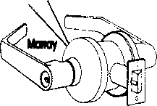

Trim  
Locks  
Hinges

Panic Devices  
Access Hardware  
Custom Modifications?

You Need To Call Marray

1-800-500-1449

Marray Enterprises, Inc., is an after-market modifier of locks, hinges, and panic devices. Located in the Silicon Valley of California, Marray uses precise computer controlled machin­ing to modify name brand hardware like Schlage, Von Duprin, Arrow, Baldwin, Bommer, PBB hinges and more! If you are looking for superior products with the best warranty, pricing, delivery and availability, call Marray. Your first source for UL listed & modified hardware.

m

Marray ***enterprises, inc.***

**At** Marray, **we’re not just modifiers, we’re Master Hardware Modifiers™**1128 Walsh Ave., Santa Clara, CA 95050. [www.marray.com](http://www.marray.com)

Reader Service #9

December 1998

***Keynotes*** 29

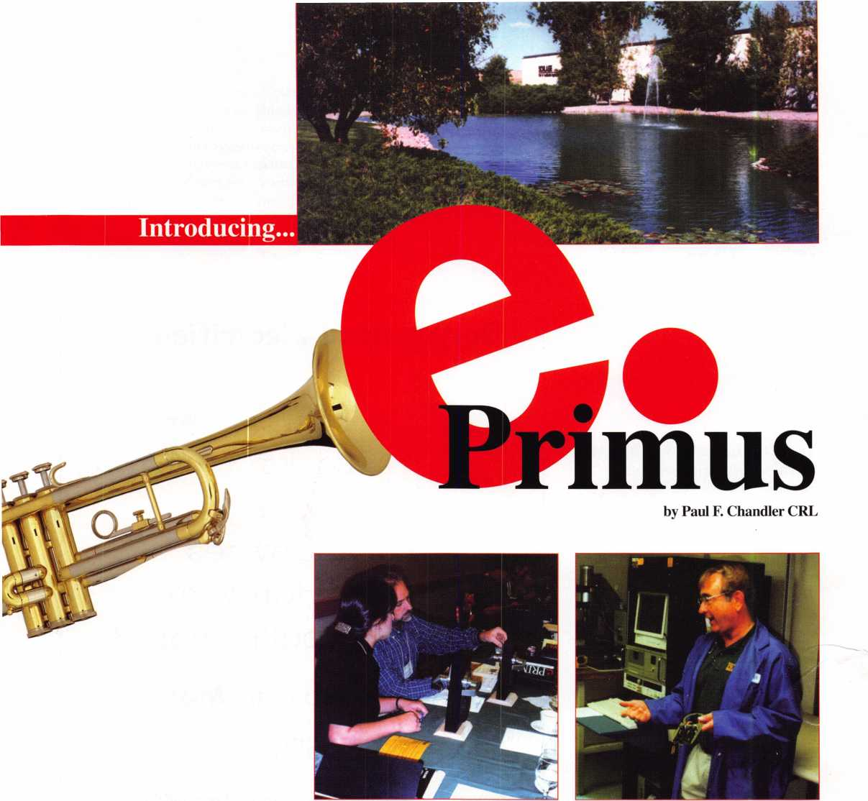

Schlage Lock Company is ready to roll out a new stand alone, self-contained access control (SASCAC) lock known as “e.Primus.” The folks at Schlage are sparing no expense to make sure that the hardware world is ready to sell and support their new lock. Part of this commitment is an aggressive training program for selected wholesale distributors and contract hardware accounts. To be an “authorized” e.Primus distributor you must send people to Colorado Springs where Schlage s professional trainers take you through installation, trouble shooting and software operations from start to finish. This training is also being offered to large end- users who purchase e.Primus for their



Keynotes

December 1998

facilities. Having just returned from Colorado Springs, I can confirm that the training was thorough and the hospitality was first rate.

e.Primus starts with Schlage Grade 1 hardware, either the “D Series” cylindrical leverset or the “L Series” mortise lock. The new product is designated “DE” for cylin­drical or “LE” for mortise. The locks may be ordered in classroom function (70) or storeroom function (80). The DE lock is available in the “Rhodes” design only, whereas the LE lock can be ordered with 06E, 07E and 93E escutcheon trims. Other trim designs and a “Vandalgard” clutched lever version are planned for the near future.

All e.Primus locks are supplied with a patented Primus high-security cylinder for mechanical key override capability.

The “e” in e.Primus refers to the addition of electronic control using Dallas Semicon­ductor “iButton” technology. An iButton is a 16mm computer chip encased in a stainless steel “MicroCan,” about the size of a stack of three dimes. Schlage e.Primus keys consist of an iButton attached to a plastic keyfob. Each iButton manufactured for Schlage has a unique electronic serial number. The e.Primus lock has a “touch receptor” on the outside trim that reads the encoded informa­tion in the iButton and decides whether to grant access or not. Since every iButton

e.Primus key is unique access can be selec-  
tively granted and total key control can be  
achieved.

Schlage offers three models of the  
e.Primus lock. Model 1 is for small, budget-  
minded installations with under 60 users and  
where sophisticated access control features  
are not required. Model 2 locks have features  
such as audit trail and are suitable for mid-  
sized facilities. Larger systems will require  
the Model 3 lock.

A unique feature of e.Primus is the ability  
to upgrade a Model 1 to a Model 2, and a  
Model 2 to a Model 3 lock very easily. Two

memory chips, which look like large  
watch batteries, can be slipped into  
holders on the Model 1 electronics  
board and it becomes a Model 2. A  
third chip can be added to complete  
the metamorphosis to Model 3.

Model 1 locks have no event  
memory and no real-time clock.

Therefore, you get no audit trail  
record of lock transactions with this  
lock. Since the Model 1 lock isn’t very  
“smart” you can program it without a  
computer. Keys can be added and

deleted with a set of color-coded “adminis-  
trator keys.” This might appeal to some end  
users who simply want to add and delete  
users without rekeying locks. Adding a new  
user key or deleting a returned key is child’s  
play. Deleting a key that you don’t get back  
is another matter. There is an administrator  
key that erases every key from the lock  
memory. Then you have to reprogram  
everyone else back into the lock, a major  
hassle. The only way to delete a single,  
unreturned key is with Schlage “RapidKey”  
software and a laptop computer. In my  
opinion, if you are going to use the software  
you may as well move up to Model 2.

Model 2 comes preset for use by 270 users and with a 460 event audit trail. You can change this to allow fewer users with a longer audit, or more users with a shorter audit (i.e. 30 users/620 audits or 930 users/20 audits). Model 2 locks cannot be programmed with “administrator keys.” You must use a laptop computer, special commu­nication cables and RapidKey software. Special gray “control” keys are programmed to transfer programming commands to locks.

Model 3 has exactly the same features but since it has more memory, it can handle more users, more audits or both. It is factory preset for 510 users and 935 audit events.

Using the “Windows ’95’’-based RapidKey software it is easy to establish a database of users and locks for any property. Then you simply issue a key to each user that is programmed only for those locks to which he or she needs access. I can attest that this is simple software to learn because I am the “crash test dummy” for any computer program. If I can learn it, almost anyone can.

RapidKey is built around “Microsoft

Access 97,” a powerful relational database program. Several user-defined fields allow you to manage all the information necessary for every door and every user in the facility. Multiple facilities can be managed with one program with no danger of unwanted crosskeying.

The minimum computer requirements for this program are: a laptop PC, Pentium 120Mhz, 32 MB RAM, 80MB hard drive, CD-ROM drive (to install) and “Windows ‘95” operating system. An available serial port, COM 1 or COM 2 will be needed.

Also, if your PC presently has Microsoft/”Access ’95” installed you will need to remove it or upgrade to “Access ’97.”

The RapidKey CD-ROM and the necessary cables for programming keys and communicating with locks must be purchased from Schlage.

At the time of this writing none of the e.Primus locks offered time control features, but they are expected by Jan. 1, 1999- The next release of the e.Primus Model 2 and Model 3 locks and RapidKey software will allow you to limit individuals access to

specific days and times of day. You will also  
be able to program locks to automatically  
enter passage mode at designated times and  
to relock at a later time. Holidays may be  
programmed into the lock memory as well.  
Existing e.Primus locks will be upgraded to  
this new version at no cost to the end user.

Taking your computer to the doors to  
download user data and to upload audit trail  
information is called “touring.” A tour  
consists of visiting each door with the laptop  
computer equipped with a special communi-  
cation cable. The end of this cable looks like  
an iButton and is held on the touch receptor

while data is being transferred. It takes  
only a few seconds at each door to  
complete the information exchange.

A number of reports can be  
generated from the data in RapidKey,  
including Door Profile Reports, User  
Access Reports, Door Audit Space  
Reports and more.

What can you do for facilities that  
want e.Primus on doors where cylin-  
drical and mortise locks are not viable,  
such as doors with panic hardware,  
aluminum/glass storefront doors and

all-glass “Herculite” doors? Well, you may  
know that Schlage is part of a bigger  
company called Ingersoll Rand. Another  
Ingersoll Rand company is Von Duprin. Von  
Duprin specializes in exit hardware and  
conventional, hardwired electronic locking  
devices such as magnetic locks and strikes.  
While Schlage developed the stand alone,  
self-contained e.Primus products, Von  
Duprin has engineered a hardwired version.  
The Von Duprin e.Primus touch receptors  
can be mounted on a door frame or in an  
electrical switch box. They are connected to a  
touch receptor controller board that is  
installed in the PS873 power supply cabinet.  
Up to four controller boards may be installed  
within a single PS873. The e.Primus  
controller boards can electrically operate a  
magnetic lock, a strike, an electric latch  
retraction exit device or anything else that  
you can connect to a dry contact relay  
output.

One of the most significant things about  
this new product is that it fits standard door  
preparations. No, I don’t mean standard plus  
a few extra holes. I mean you slip out a “D”

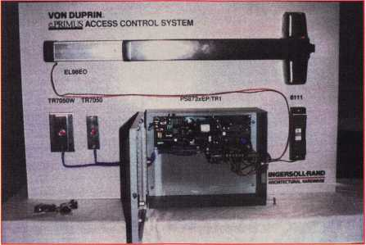

December 1998

Keynotes

and you slip the “DE” back in the existing  
holes. The mortise lock also uses the standard  
“L” series escutcheon trim prep.

Schlage e. Primus locks are powered by  
four alkaline “AA” batteries. In typical appli-

cations you will need to change the  
batteries only once a year.

A four tone warble sound is made  
when batteries are getting low. If the  
low battery warning is ignored and  
the lock completely shuts down you  
can still open the door with your  
mechanical override Primus key.

There is also an external battery pack  
that can be used to power up the  
lock one time for iButton access.

Unlike many SASCAC products  
that have appeared in recent years  
that are large and boxy-looking,

e.Primus is very compact. The mortise trim  
uses the standard “E” escutcheon plate. The  
“D” series rose is teardrop shaped, rather than  
circular, to accommodate the touch receptor.

On the inside of the door there is a thin compartment containing the batteries and electronics. The low profile appearance looks good and allows e.Primus to blend with normal door hardware.

Schlage’s entry into the SASCAC market is not the most sophisticated or the most innovative Eve seen. On the other hand, it has several strong features. The hardware,

electronics and keys are solid and  
dependable. The software is simple to use  
but flexible. Schlage has committed consid-  
erable resources for training, technical  
support and marketing of e.Primus.

And most important, they are  
SCHLAGE. They will use their  
dominant market position and well-  
trained sales force to introduce stand  
alone, self-contained access control to  
the architects, security directors,  
facilities managers and other  
consumers who look to them for  
security guidance. Schlage contract  
hardware dealers will get the product  
specified in new construction as a  
cost-effective alternative to hardwired  
access control. Those Schlage distrib-  
utors who commit to this product

will partner with the manufacturer to assure  
that inventory is available and service is  
provided. e.Primus has arrived and I believe  
it is here to stay.

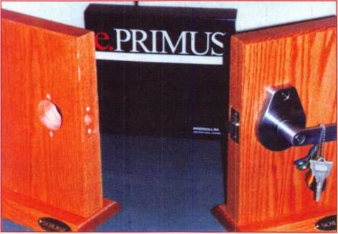

"S&G... the professional's choice when only the best will do!"

6120... the retrofit choice.

6120 lock body with brushed chrome key pad Regular price $139

Sale price $113.95 each

Purchase 3 or more and

pay only $99.95 each

(prices good while supplies last!)

December 31# 1998

798 TIME ♦ 785 232 8705 / Fax 785 232 2603

Sale Ends

Time-Master.com (web) ♦ [timstr@AOL.com](mailto:timstr@AOL.com) (email) ♦ 888 798 8464 / Fax 800

Reader Service #10

—-T

Keynotes

December 1998

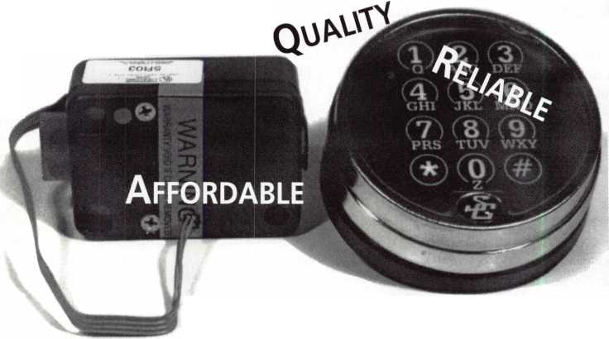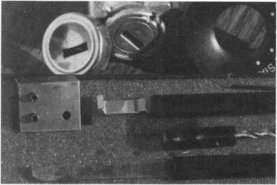

The Innovator

1 998 and up GM in-dash ignition removal kit.

Patent #5.454.245.

Removes plastic ring and chrome cap in seconds; makes access hole to pick side bar in, turns cylinder to acc. position. Removes lock in less than five minutes with no damage to lock! Your first job will more than pay for the kit.

Introductory price: $65 (plus $3 for S&H)

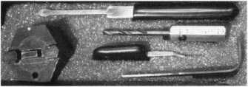

1996 and up 8 Waffer Ford Ignition

Removal Kit and Side Bar Breaker Tool

Patented 5,701,773

Turn ignition to "ON" position in less than (60 seconds) for fast  
removal or use kit to push side bar in. then turn cylinder to "ON"

position without any damage. Fit key, replace same lock. $90.00 + $3.00 S &H

FINISHED LOCK

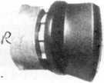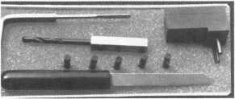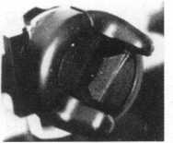

1994 and up 9 Waffer GM Ignition Removal Tool Kit

Patent 5,454,245

A new system for the future. These locks have side bars longer than the  
old type and must be in the "ON" position to remove the cylinder. My  
tool will do this. Best of all, you will not damage the cylinder. You can

repair, kit key and replace the same cylinder. Do only one job and you will have the price of the kit paid  
for. A replacement cylinder costs about $22.00, VATS $45 our cost. Order one today at my special  
introductory price, and be prepared for these new locks. $60.00 + $3.00 S&H  
***UPGRADE IT FOR '95 BLAZERS, SUBURBANS, S-10 PICK UPS, ETC ... $20.00 + $3.00 S&H ***

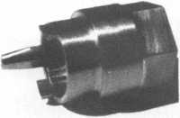

FORD QUICK-ON

PATENT 5,402,661

Now turn most 10 cut ignition  
cylinders to the "ON" position  
for fast removal—in less than

60 seconds. Sable, Taurus, all styles, even with airbags.  
No damage to housing. $65.00 +$3.00 S&H

The GM Persuader patented

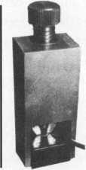

The No-Nonsense Squeeze Lock Plug Remover Patent 5,165,158

Now you can remove all squeeze lock plugs in 15 seconds or less, from all GM, Ford, Chrysler, AMC, Jeep, no more fumbling, gadgets, cut fin­gers, broken tabs, need for 3 hands for removal of lock. It's so easy, you can do it in the dark, while it's still in the glove box.

$45.00 + $300 S&H

This unique tool will open virtually all GM trunks and doors, through the current year, where tool fits into the  
cylinder core cavity, in less than 50 seconds. No drilling, pulling, picking, special tools, or electric needed.  
When customer's key does not open trunk because: Problem 1) spring retainer popped up into outer shell;  
Problem 2) one side of side bar sprung off side bar does not retract; Problem 3) key or cylinder worn side  
bar does not retract; Problem 4) key jammed in lock in "turned" position, etc. With The Persuader you will

open these locks in less than 50 seconds. No damage to lock, just repair and  
replace, nothing to wear out. Yes if needed, it will open with no key. Note:  
because of The Persuader's capabilities, it will be sold to locksmiths only.

$45.00 + $3.00 S&H

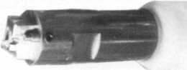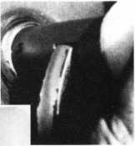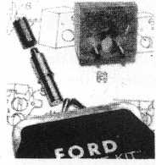

Ford Disc-Out Kit  
Patent #4,682,398

A tool kit to remove those stubborn Ford pin ignition locks from 1976 through  
the current year. These locks incorporate (2) locking devices and a hard steel  
disc across the shear line. They must be in the "ON" position, to release both  
locking devices, so as not to damage the housing. I guarantee the job to take  
5 minutes with my kit. Complete Kit $55.00 + $3.00 S&H

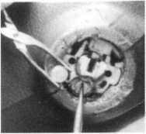

Aable Locksmith ▼ 91-10 Liberty Avenue ▼ Ozone Park New York 11417 ▼ 718 847 1377 ▼ Fax 718 847 0991

Frank Markisello guarantees all of his products to do as stated or your money back!

Reader Service #11

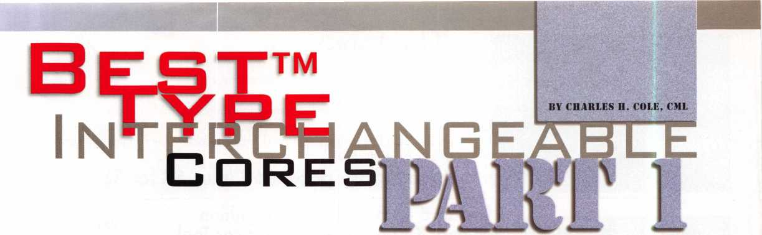

CHART 1 For many years, Best Locking Systems was

|  |  |  |  |  |
| --- | --- | --- | --- | --- |
| Number | Bottom | Top | Key | the only manufacturer of interchangeable |
| Value | Pin | Pin | Depth | core locks. Interchangeable cores (IC s), keys for IC s, pinning kits and housings are |
| □ | . 1 1 □ | _ | s |
| 1 | . 1 22 | - | .3 1 B | available from a number of manufacturers today. Even so, when locksmiths speak of |
| 2 | .135 | .025 | .305 | this type of interchangeable core locks they |
| 3 | . 1 47 | .037 | .293 | usually refer to them as Best locks, even |
| 4 | . 1 SO | .050 | .2BO | when the manufacturer may actually be |
| 5 | . 1 72 | .062 | .2 SB | Arrow, Eagle, Falcon, KSP or some other |
| 6 | . 1 S 5 | .075 | .255 | company. |
| 7 | . 1 97 | .□B7 | .243 | There are three Best interchangeable core systems, A2, A3 and A4. The most |
| B | .2 1 □ | . 1 □□ | .230 | common, and the only one that most |
| 9 | .222 | .112 | .2 1 B | locksmiths ever encounter, is the A2 system. |
| 1 □ | - | . 1 25 | .205 | The only difference between the three |
| 1 1 | - | . 1 37 |  | systems is the increment each uses. The |
| 1 2 |  | . 1 50 |  | increment is .0125" for the A2 system, .018" |
| 1 3 | - | . 1 62 |  | for the A3 system and .021" for the A4 system. The same core may be used for all |
| 1 4 |  | . 1 75 |  | three systems. Because the increments are |
| 1 5 | — | . 1 B 7 |  | different, the pin stack for each is also |
| 1 6 | - | .200 |  | different. We will discuss only the A2 |
| 1 7 | - | .2 1 2 |  | system, which has a pin stack of 23. This |
| 1 B | _ | .225 |  | means that the total numerical value of all of |
| 1 9 | - | .237 |  | the pins in each chamber must add up to 23. There are two types of IC pins, bottom |

and top. Top pins are used as master pins, control pins and driver pins. Each pin is given a numerical value, based on its length. The chart on the left shows the number and actual measurement for each pin. The key cut depths for each of the 10 depths are also shown. Notice that the smallest top pin is a number 2, .025", and the largest top pin is a number 19, .237". Notice also that there is a number zero bottom pin and the longest bottom pin is a number 9- Depths on the keys can vary from 0 to 9, for 10 possible depths.

There will always be a minimum of a bottom pin, a control pin and a driver pin in each chamber. The pin stack always adds up to 23. There could be a number 9 bottom pin, a number 10 control pin and a number 4 driver pin, making the total add up to 23.

This is the most extreme possibility. The cuts on the operating (change) key and the control key would both be a number 9 depth for that chamber in that instance.

Interchangeable cores have two shear lines. One shear line operates the lock and the other shear line operates the control lug on the core that holds the core housing.

There is a 10-number difference between the two shear lines. The control shear line is ten numbers higher than the operating shear line. This explains the pins in the previous paragraph.

There is also a constant factor between the driver pins and the bitting of the control key. It is possible to make a control key merely by carefully taking out the driver pins and measuring them. Using the chart, measure the driver pins and assign the proper number to each. Subtract that number, chamber by chamber, from 13 to determine the actual cuts for the control key.

Most factory established IC systems are designed to have a master and a grand master key, making the systems three level. Many factory established systems are even higher level systems, often higher level than necessary. There are several reasons why this is not a good practice.

First of all, this causes an excessive number of pins to be placed into each core. The more pins there are in a core the less security there is with that core. Each additional top/master pin creates one or more shear lines within the pin stack. This means more keys than necessary or desired can operate the core. This also means the core is more easily picked.

Too many pins in a core also means that some of the pins must be smaller. This can result in cores that malfunction with usage due to pins becoming jammed. The cores that seem to always have the most pins in them are those that are used by the most people and have the highest frequency of usage, such as an employee entrance.

December 1998

341 Keynotes

injphation on

Street Address

6. Is there anything in particular that you would like to see ALOA add to the web page in the future?

7. General comments about [www.aloa.org](http://www.aloa.org):

Use this card to obtain more information about the products and services advertised or described in this issue.

**Card valid until Dec. 1.1999.**

Use this card to obtain more information about the products and services advertised or described in this issue.

**Card valid until Dec. 1,1999.**

State

Country

FAX

Phone

Card valid until Dec 1r 1999.

ALQA WEB PAGE FEEDBACK

City StateCountry ZIP. PhoneFAX

Name _

_Title

Company Street Address

|  |  |  |
| --- | --- | --- |
| 1. Are you on-line? | ONo | O Yes |
| 2. Do you plan to get on-line in the coming year? | ONo | O Yes |
| 3. If on-line, were you aware of theALOA home page ([www.aloa.org](http://www.aloa.org))? | ONo | O Yes |
| 4. Do you have a favorite feature on the ALOA web page? | ONo | O Yes |

If so, which one?

5. Do you find any of the features on the ALOA web page problematic? O No O Yes

If so, which one and why?

Reader Service

December 1998

numbfcr for information on each item.

|  |  |  |  |  |  |  |  |  |  |  |  |  |  |  |  |  |  |  |  |
| --- | --- | --- | --- | --- | --- | --- | --- | --- | --- | --- | --- | --- | --- | --- | --- | --- | --- | --- | --- |
| i | 6 | 11 | 16 | 21 | 26 | 31 | 36 | 41 | 46 | 51 | 56 | 61 | 66 | 71 | 76 | 81 | 86 | 91 | 96 |
| 2 | 7 | 12 | 17 | 22 | 27 | 32 | 37 | 42 | 47 | 52 | 57 | 62 | 67 | 72 | 77 | 82 | 87 | 92 | 97 |
| 3 | 8 | 13 | 18 | 23 | 28 | 33 | 38 | 43 | 48 | 53 | 58 | 63 | 68 | 73 | 78 | 83 | 88 | 93 | 98 |
| 4 | 9 | 14 | 19 | 24 | 29 | 34 | 39 | 44 | 49 | 54 | 59 | 64 | 69 | 74 | 79 | 84 | 89 | 94 | 99 |
| 5 | 10 | 15 | 20 | 25 | 30 | 35 | 40 | 45 | 50 | 55 | 60 | 65 | 70 | 75 | 80 | 85 | 90 | 95 | 100 |

Card valid until Dec. 1,1999.

fch item.

Reader Service

nGyttOtGS December 1998

Name

Title

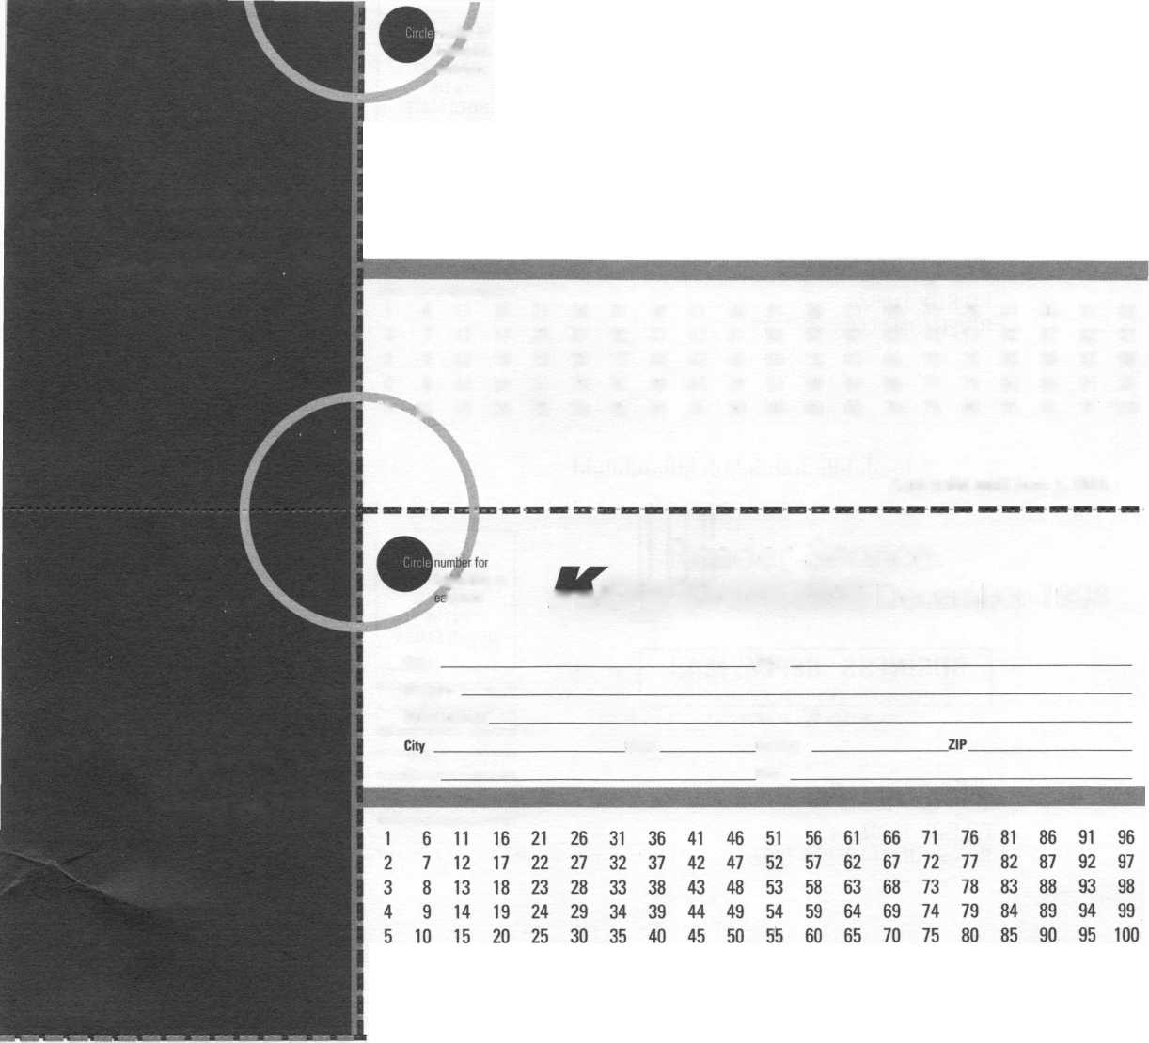

BUSINESS REPLY MAIL

FIRST-CLASS MAIL PERMIT NO 16501 DALLAS TX  
POSTAGE WILL BE PAID BY ADDRESSEE

PO BOX 11602 RIVERTON NJ 08076-7202

MlM.l..l.llmlml.ll..l.„l,.1.111 1.II..U

BUSINESS REPLY MAIL

FIRST-CLASS MAIL PERMIT NO 16501 DALLAS TX  
POSTAGE WILL BE PAID BY ADDRESSEE

PO BOX 11602 RIVERTON NJ 08076-7202

llliiili.lilliiiliiililliiliiiliilillliiiiililliilil

|  |  |
| --- | --- |
| NO POSTAGE NECESSARY | 1  1  I1  1  r  1  1 |
| IF MAILED | 1  1  1  1  1 |
| IN THE |
| UNITED STATES | 1  1  !  1  1 |

NO POSTAGE  
NECESSARY  
IF MAILED  
IN THE

UNITED STATES

P Lace Stamp Here

ALOA WEB PAGE FEEDBACK

Associated Locksmiths of America, Inc. 3003 Live Oak Street Dallas, TX 75204

Always use the lowest possible level master key system that will serve your needs. Put no more master pins in a core than are absolutely necessary.

It is very important to maintain control and restrict the control key, probably more important than it is to restrict the top master key. The control key is used to remove and replace cores. A person with the control key could remove the cores, leaving the lock to be opened by a screwdriver or just about anything. A person with a control key could swap cores around to create havoc within the facility. The control key will remove even those cores that are not pinned to be operated by the top master key.

Because the increment for these A2 systems is .0125", you must use a two step master key system when these cores have to operate from both a change key and a master key or master keys. This makes it necessary to stay within the same off-even pattern for the change keys and master keys within a given chamber. There is no necessity for maintaining any odd-even relationship between the change keys and master keys with the control key bitting, however. The cuts on the control key may be either odd or even for any chamber without regard for what the odd-even pattern is for the master keys and change keys.

A Sample Two Level System

The first thing we would normally do is select the bitting for the top master key, in this case the master key. We want one cut to be more shallow than the cuts on any change key for that chamber. We also want one cut on the master key to be deeper than the cuts on any change key for that chamber.

The reason for this is to prevent a change key from being cut down to make it into a master key. Of less importance, but also to be considered, is preventing a master key from being altered to make it a change key.

We want the master key to be relatively strong, so we do not want very deep cuts near

the bow. Remember, cuts go from tip to bow on I.C.’s, so we will put the deep cuts near the start of the bitting and the shallow cuts later on in the bitting. You must also avoid using the same bitting or even the same bitting pattern on numerous master keying jobs, however.

Let’s use 694 5 6 1 as the bitting for the master key in this example.

Next we need to determine how many change keys we will need. Since this is a two step system with ten depths, we will get 4 change keys when we put a master pin in one chamber, 16 change keys for 2 chambers, and so on according to the list in the following chart.

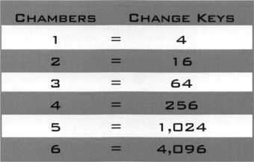

These numbers are the theoretical, or mathematically possible, number of change keys. They do not take into consideration the some of the combinations would not be usable due to depth differences between adjacent cuts. This factor is referred to as the Maximum Adjacent Cut Specification (MACS).

Because the increment, or drop, for the IC A2 system is only .0125", you can have a 0 depth next to a 9 depth. The maximum adjacent cut specification is 9. You could not have a series of three or more cuts such as 0- 9-0 or 9-0-9, however. There would not be enough of the root cut of the key left on the shallow cuts of those three cuts to properly seat the tumbler.

When there is a grand master key, we also have to consider what effect that will have on the change key possibilities. That might become important with systems where there were a very large number of change keys.

Let’s say we only want 16 change keys for

this sample system. Here is how the progres­sion might look:

|  |  |  |  |  |  |
| --- | --- | --- | --- | --- | --- |
| MK | 6 | 9 | 4 | 5 6 | 1 |
|  | - | - | - | B | 3 |
|  | - | - | - | □ | 5 |
|  | - | - | - | 2 | 7 |
|  | - | - | - | 4 | 9 |

Dashes indicate that there are no master pins in the first four chambers.

We would progress only the last two chambers, giving us the following 16 change keys:

|  |  |  |  |
| --- | --- | --- | --- |
| 694583 | 6945D3 | 694523 | 694543 |
| 694585 | 6945D5 | 694525 | 694545 |
| 694587 | 6945D7 | 69452V | 69454V |
| 694539 | 6945D9 | 694529 | 694549 |

Next month we will select a control key, pin up a core and show procedures for removing a core when no control key is available.

December 1998

Keynotes L_

**Associate**

Members

|  |  |
| --- | --- |
| Manufacturers | Arrow Lock Company  10300 Foster Avenue  Brooklyn, NY 11236 (718) 257-4700; FAX (718) 649-9097 |
|  | • Ml |
| A & B Safe Corp.  171 S. Delsea Dr.  Glassboro, NJ 08028 (800) 253-1267; FAX (609) 863-1208 | Auto Security Products (A. S. P.)  P.O. Box 10  Redmond, WA 98073-0010 (425) 556-1900; FAX (425) 558-1205 |
| (0 (j^ ^ | • • |
| ASSA Inc.  10300 Foster Ave.  Brooklyn, NY 11236 (800) 235-7482; FAX (718) 257-2772 | BWD Automotive  900 Ravenwood Dr.  Selma, AL 36701  (334) 874-9001; FAX (334) 874-6011 |
| • | • • |
| Abus Lock Company  3555 Holly Lane North  Plymouth, MN 55447-0507 (800) 352-2287; FAX (612) 509-9939 | Chicago Lock Company  10100 88th Ave.  Pleasant Prairie, Wl 53158-0069 (800) 445-3204; FAX (414) 947-7178 |
| • | • |
| Adams Rite Manufacturing Co.  P.0. Box 1301  LaPuente, CA 91749-1301 (562) 699-0511; FAX (562) 699-5094 | Corbin Russwin Architectural Hardware  P.O. Box 25288  Charlotte, NC 28229 (800) 543-3658; FAX (800) 447-6714 |
| • • | sees |
| Adesco Safe Manufacturing Co.  16720 S. Garfield Ave.  Paramount, CA 90723 (800) 821-6803; FAX (310) 408-6427 | Curtis Industries  6140 Parkland Blvd, Ste. 300  Mayfield Heights, OH 44124-4103 (800) 555-5397 |
| • | • • |
| Adrian Steel Company  906 James St.  Adrian, Ml 49221  (800) 677-2726; FAX (517) 265-5834 | DETEX  302 Detex Dr.  New Braunfels, TX 78130 (800) 729-3839; FAX (830) 620-6711 |
| e | • • • • |
| Alarm Lock Systems, Inc.  345 Bayview Ave.  Amityville, NY 11701 (800) ALA-LOCK; (516) 789-3383 | Don-Jo Manufacturing, Inc.  P.O. Box 929  Sterling, MA 01564 (508)422-3377; FAX (508) 422-3467 |
| • | • • |
| Aiphone Intercom Systems  1700-130th Avenue, NE  Bellevue, WA 98005 (425) 455-0510; FAX (425) 455-0071 | Door Controls International  2362 Bishop Circle East  Dexter, Ml 48130  (800)742-3634; FAX (800) 742-0410 |
| see | • • • • |
| American Lock Co.  3400 West Exchange Road  Crete, IL 60417-2099 (708) 534-2000; FAX (708) 534-0531 | ESP Lock Products, Inc.  375 Harvard Street  Leominster, MA 01453 (508)537-6121; FAX (508) 537-1699 |
| • • | • |
| American Security Products (AMSEC)  11925 Pacific Ave.  Fontana, CA 92337-6963 (800) 423-1881; FAX (909)685-9685 | Folger Adam Security, Inc.  16300 W. 103rd Street  Lemont, IL 60439  (630) 739-3900; FAX (630) 739-6138 |
|  | • • |
|  |  |



Associate members of the Associated Locksmiths of America (ALO A) manu­facture or distribute materials or equip­ment, or provide services, for the securi­ty industry. Many have donated money, services and equipment to ALOA in addition to their annual dues. Their sup­port of ALOA projects enhances overall membership benefits and we encourage our members to patronize these firms. ^ you know of a potential candidate for -v associate membership, please contact the ALOA Sales staff at (214) 827-1701. Associate member dues are $500 per year and entitle the payor to use the ALOA logo, and selected discounts on ALOA products and services.

, : ■

# Alarms: Personal, vehicle, electronic, fire, burglar, and exit

® Automotive: Lockout equipment, key chains/rings

® Builders Hardware: Door closers, fumiture/decorative hardware, viewers, emergency exit devices

® Business/Technical & Educational: Books, reference guides, publications, computer software

© CCTlf/Photo Imaging: Cameras, monitors, photo ID equipment, cables

© Electric/Electronic Security: Card access control and readers, surveil­lance, electric/magnetic locks and strikes, keypads

© Lock Devices: Auto locks, cylinders, emergency exit/entrance control, locks (various types), strikes

© Tools & Supplies: Key blanks, cutters, picks, rings/hooks, custom van/truck supplies



***Keynotes***

December 1998

|  |  |  |
| --- | --- | --- |
| Fort Lock Corp.  3000 N. River Rd.  River Grove, IL 60171 (708) 456-1100; FAX (708) 456-9476 | La Gardf Inc.  3330 Kashiwa Street  Torrance, CA 90505 (310) 325-5670; FAX (310) 325-5615 | Rutherford Controls Inc.  2697 International Pkwy, Bid 5 #100  Virginia Beach, VA 23452 (757) 427-1230; FAX (804) 427-9549 |
| •••••• | • • • | 9 |
| Grobet File Co. of America  750 Washington Ave.  Carlstadt, NJ 07072  C800) 962-7242; FAX (800) 243-2432 | Lori Lock  P.O. Box 1040  Southington, CT 06489 (860) 621-3605; FAX (203) 621-5972 | STRATTEC Security Corp.  3333 W. Good Hope Rd.  Milwaukee, Wl 53209 (414) 247-3333; FAX (414) 247-3329 |
| • | • t | 9 9 9 |
| H.E.S., Inc.  2040 W. Quail Ave.  Phoenix, AZ 85027 (602) 582-4626; FAX (602) 582-4641 | Lucky Line Products  7890 Dunbrook Rd.  San Diego, CA 92126 (619) 549-6699; FAX (619) 549-0949 | Sargent & Greenleaf, Inc.  P.O. Box 930  Nicholasville, KY 40340-0930 (606) 885-9411; FAX (606) 887-2057 |
| • • • | • | (J) @ ^ |
| HPC, Inc.  3999 N. 25th Avenue  Schiller Park, IL 60176 (847) 671-6280; FAX (847) 671-6343 | M.A.G. Engineering & Mfg. Inc.  15261 Transistor Lane  Huntington Beach, CA 92649 (714) 891-5100; FAX (714) 892-6845 | Schlage Lock Co.  1915 Jamboree Suite 165  Colorado Springs, CO 80920 (800) 847-1864; FAX (800) 452-0663 |
| • • • | • • • | • 9 |
| llco Unican  400 Jeffreys Road  Rocky Mount, NC 27804 (919) 446-3321; FAX (919) 446-4702 | MARKS USA  5300 New Horizons Blvd.  Amityville, NY 11701 (516) 225-5400; FAX (516) 225-6136 | Schwab Corporation  3000 Main St  Lafayette, IN 47903-5088 (765) 447-9470; FAX (765) 447-8278 |
| ••••••• | • | 9 |
| In Out Systems, Inc.  3650-B Matte Boulevard  Brassard, Quebec J4Y-2Z2, Canada (514) 444-5949; FAX (514) 444-2029 | MUL-T-LOCK USA, Inc.  300-1 Route 17 South Suite A  Lodi, NJ 07644  (800) 562-3511; FAX (973) 778-4007 | Securitron Magnalock Corp.  550 Vista Blvd.  Sparks, NV 89434  (800) 624-5625; FAX (702) 355-5636 |
| • • | • • • | • • |
| Intellikey  551 S. Apolo Boulevard, Suite 204  Melbourne, Florida 32901 (800) 226-0703; FAX (407) 724-0811 | Master Lock Company  2600 North 32nd Street  Milwaukee, Wl 53211 (414) 444-2800; FAX (414) 449-3114 | Security Door Controls  3580 Willow Lane  Westlake Village, CA 91361 (805) 494-0622; FAX (800) 959-4732 |
|  | • • | • |
| Jet Hardware Mfg. Co.  800 Hinsdale Street  Brooklyn, NY 11207 (718) 257-9600; FAX (718) 257-0973 | Medeco Security Locks  P.O. Box 3075  Salem, VA 24153  (540)380-5000; FAX (540) 380-5010 | Security Solutions  1640 W. Hwy. 152  Mustang, OK 73064 (405) 376-1600; FAX (405) 376-6870 |
| 9 | • • • | 9 9 9 |
| KABA High Security Locks  P.O. Box 490  Southington, CT 06489 (860) 621-3601; FAX (860) 621-9727 | Meilink Safe Company  111 Security Parkway  New Albany, IN 47150 (800) 634-5465; FAX (800) 896-6606 | Sentry Group  900 Linden Ave.  Rochester, NY 14625-2784 (716) 381-4900; FAX (716) 381-8559 |
| • | • | • |
| KEY-BAK; Div. of W. Coast Chain Mfg. Co.  1460 S. Balboa Ave.  Ontario, CA 91762 (909) 923-7800; FAX (909) 923-0024 | NKL Industries Ltd.  1111-13 Cavalier Blvd.  Chesapeake, VA 23323 (800) 528-9900; FAX (757) 485-0271 | Sully Tools Inc.  3515 Nodding Pine Ct.  Fairfax, VA 22033  (703) 689-3416; FAX (703) 787-0869 |
| • • • • | • • • • | 9 9 9 |
| Knaack Manufacturing Co.  420 E. Terra Cotta Ave.  Crystal Lake, IL 60014 (800) 456-7865; FAX (815) 459-9097 | National Cabinet Lock  200 Old Mill Road, P. 0. Box 200  Mauldin, SC 29662 (864) 297-6655; FAX (864) 297-9987 | TIB Canada Ltd.  2164 Oneida Crescent  Mississauga, Ontario, Canada L5C IV6 (905) 566-9198; FAX (905) 566-9697 |
| • | 9 | • 9 9 9 9 |
| LAB Security  700 Emmett St.  Bristol, CT 06010  (800) 243-8242; FAX (203) 583-7838 | Newman Tonks  805 N Buckman St  Shepardsville, KY 40165 (800) 826-5792; FAX (800) 777-8229 | Taymor Industries, Inc.  1586 Zephyr Ave.  Hayward, CA 94544 (800) 388-9887; FAX (800) 288-8133 |
| • | 9 9 | 9 9 |
| LCN Closers (Division of Ingersol)  121 W. Railroad Ave.  Princeton, IL 61356 (815) 875-3311; FAX (815) 875-3222 | ROFU International Corp.  2004-B 48th Ave.; Court E  Tacoma, WA 98424 (800) 255-7638; FAX (253) 922-1728 | Trine Products Corporation  1430 Ferris Place  Bronx, NY 10461  (718) 829-4796; FAX (718) 792-9127 |
| • | 9 9 9 | 9 9 9 |
|  |  |  |

December 1998

Keynotes

37

|  |  |  |
| --- | --- | --- |
| Weiser Lock Company  6700 Weiser Lock Blvd.  Tucson, AZ 85746  (502) 741-6338; FAX (520) 741-6363  t ® | DiMark International  3117 Liberator St., Unit A  Santa Maria, CA 93455 (800) 235-2435; FAX (805) 928-8034  9 9 | Hardware Agencies, Ltd.  1220 Dundas Street East  Toronto, ON M4M 1S3 (416) 462-1921; FAX (414) 462-1922  00000000 |
| Yale Security Inc.  P.0. Box 25288  Charlotte, NC 28229-8010 (800) 438-1951; FAX (800) 338-0965  • • • • | Dire’s Lock & Key Co.  2201 Broadway  Denver, CO 80205  (303) 294-0176; FAX (303) 294-0198  ••••••••••• | Hardware Suppliers of America  P.O. Box 2208  Winterville, NC 28590 (800) 334-5625; FAX (800) 334-5635  9 9 |
| Zhongshan Hua Feng Lock Products  S Yongning Industrial Road, Ziaolan Zhongshan Guangdong, China  86-760 227 82 63; FAX 86-270 227 80 63  m | Direct Security Supply, Inc.  36 Lincoln Street  Boston, MA 02135 (800) 252-5757; FAX (800) 452-8600  ^ ^ @ <!^ (p (Q ^ | IDN, Inc.  1000 S. Main, Suite 280  Grapevine, TX 76051 (817)421-5470; FAX (817) 421-5468  0000000000 |
| Distributors | Doyle Lock Supply  2211 W. River Road N.  Minneapolis, MN 55411 (800) 333-6953; FAX (612) 521-0166 | Intermountain Lock & Supply Co  3106 South Main Street  Salt Lake City, Utah 84115 (800) 453-5386; FAX (801) 485-7205  •••••••••• |
| Accredited Lock Supply Co.  P.O. Box 1442  Secaucus, NJ 07096-1442 (800) 652-2835; FAX (201) 865-5031  ^ @ d) ^ | Dugmore & Duncan Inc.  30 Pond Park Rd.  Hingham, MA 02043 (800) 225-1595; FAX (617) 740-4043  ••••••• | JLM Wholesale, Inc.  3095 Mullins Ct  Oxford, Ml 48371-1643 (800) 522-2940; FAX (800) 782-1160  9 9 9 |
| Ace Lock & Security Supply Co.  565 Rahway Ave.  Union, NJ 07083-6631 (800) ACE-LOCK; (800) ACE-FAX4 | E. L. Reinhardt Co., Inc.  3250 Fanum Road  Vadnais Heights, MN 55110 (800) 328-1311; FAX (612) 481-0166  •••••• | Jo-Van Distributors Inc.  929 Warden Ave.  Scarborough, Ontario MIL 4C6 (416) 752-7249; FAX (416) 752-3845  00000000000 |
| Akron Hardware Consultants, Inc.  2579 South Arlington Road  Akron, OH 44319  (800) 321-9602; FAX (800) 328-6070  • • • | Ewert Wholesale Hardware  4709 W 120th St  Alsip II 60658  (800) 451-0200; FAX (708) 597-0881  • • • • • | Lockmasters, Inc.  5085 Danville Road  Nicholasville KY, 40356 (606) 885-6041; FAX (606) 885-7093  9 9 9 9 |
| American Security Distribution  4411 E. La Palma  Anaheim, CA 92807 (714) 996-0791; FAX (714) 579-3508  ••••••• | Fairway Supply, Inc.  2631 Lombardy Lane  Dallas, TX 75220  (214) 350-0021; FAX (214) 352-4299  ^ <§}} @ <0 (0 (H 0 | Locks Company  2050 N.E. 151 St.  N. Miami, FL 33162 (800) 288-0801; FAX (305) 949-3619  ••••••• |
| Andrews Wholesale Lock Supply  544 S. 9th St  Lebanon, PA 17042-6608 (717) 272-7422; FAX (717) 274-8679  • | Foley-Belsaw Company  6301 Equitable Road  Kansas City, MO 64120 (800)821-3452; FAX (816) 483-5010  • • • • | The Locksmith Store Inc.  1229 E Algonquin Rd. Suite E  Arlington Heights, IL 60005 (847) 364-5111; FAX (847) 364-5125  • • • • |
| Boyle & Chase Inc.  P. 0. Box 74  Accord, MA 02018-0074 (800) 325-2530; FAX (781) 335-5342  9 9 9 | Fried Brothers, Inc.  467 N. 7th St.  Philadelphia, PA 19123 (800) 523-2924; FAX (800) 541-3489  •••••••••• | M. Zion Company  69 Reade Street, 4th Floor  New York, NY 10007 (212) 349-8677; FAX (212) 964-0495  0 0 0 0 0 0 0 |
| Clark Security Products, Inc.  4775 Viewridge Ave.  San Diego, CA 92123-1641 (800) 854-2088; FAX (619) 974-5284 | HS&S Wholesale Distributors  12915 West 8 Mile Road  Detroit Ml 48235  (800) 521-2202; FAX (313) 342-7580  <0 (0 (0 (0 (0 (0 0 | McDonald-DASH Locksmith Supply  5767 E. Shelby Dr.  Memphis, TN 38141 (800) 238-7541; FAX (901) 366-0005  00000000 |
| Cook’s Building Specialties  2441 Menaul Blvd. NE; P.O. Box 37320 Albuquerque, NM 87176-7320 (505) 883-5701; FAX (505) 883-5704  •••••• | Hans Johnsen Company  8901 Chancellor Row  Dallas, TX 75247  (214) 879-1550; FAX (214) 879-1530  00000000 | McManus Locksmith Supply, Inc.  P.O. Box 9231,1309 Central Ave.  Charlotte, NC 28299 (702) 333-9112; FAX (704) 332-8664  9 9 9 |
|  |  |  |
| m»s;, ® Business/Tech & Ed. a .  9 CCTV/PhotoImaging A I, ?,5uPpfces  ■: :V!' ■  r ® Lock Devices . . , ® Ofter - | | |

***Keynotes***

December 1998

|  |  |
| --- | --- |
| McMaster-Carr Supply Company  600 County Line Rd,  Elmhurst IL 60126-2081 (630) 833-0300; FAX (630) 834-9427  999999 | Service |
| Monaco Lock Co.  339-345 Newark Ave.  Jersey City, NJ 07302 (800) 526-6094; FAX (800) 845-LOCK  • • • | Alarm Monitoring Service, Inc.  5021 Fairfield St.  Metairie, LA 70006 (504) 454-2163; (504) 456-8737  9 |
| Omaha Wholesale Hardware  1201 Pacific Street, PO Box 3628  Omaha, NE 68108 (800) 238-4566  eeeeeeee | Allstate Insurance Company  2775 Sanders Road, Suite A5  Northbrook, IL 60062 (847) 402-8196; FAX(847) 326-7509  9 |
| Security Lock Distributors  40 A Street  Needham Heights, MA 02194 (800) 847-5625; FAX (800) 878-6400  • • • | GEICO  One Geico Blvd.  Fredericksburg, VA 22412 (540) 286-4399; FAX (540) 286-7106  9 |
| Sentry Security Fasteners  8109 N. University  Peoria, IL 61615  (309) 693-2800; FAX (309) 693-2872  • 9 | The Hartford Financial Services Co.  55 Farmington Ave.; P.O. Box 2908  Hartford, CT 06104 (860) 520-2915; FAX (860) 520-2264  9 |
| Southern Lock and Supply Co.  Box 1980,10910 Endeavor Way  Pinellas Park, FL 34664 (800) 237-2875; FAX: (800) 447-2299 | Locksmith Publishing Corp.  850 Busse Hwy.  Park Ridge, IL 60068 (847) 692-5940; FAX (847)692-4604  9 |
| Stone & Berg Wholesale  99 Stafford Street  Worcester, MA 01603 (800) 225-7405; FAX (800) 535-5625  •••••••••• | The National Locksmith Magazine  1533 Burgundy Parkway  Streamwood, IL 60107 (630) 837-2044; FAX (630) 837-1210  9 |
| Strauss Safe & Lock Company  1801 Second Avenue  Des Moines, IA 50314 (515)288-9571; FAX: (515)288-9752  • ••••• | Pine Technical College  1000 4th Street  Pine City, MN 55063 (800)521-7463; FAX (320) 629-7603  9 |
| Timemaster, Inc.  127 SE 29th Street  Topeka, KS 66605  (785) 232-8705; FAX (800) 798-8463  ^ | Unlocks, Inc.  3505 Tarpon Woods Blvd. G409  Palm Harbor, FL 34685 (800) UNLOCKS; FAX (813) 787-7960 |
| Top Notch Distributors, Inc.  3151 Goni Rd.  Carson City, NV 89706-7922 (800) 722-4210; FAX (800) 248-3620  • • • |  |
| Turn 10  P. O. Box 746  Marietta, OH m45750 (800) 848-9790; FAX (800) 391-4553  9 9 |
| U.S. Lock Corporation  77 Rodeo Drive  Brentwood, NY 11717 (800) 925-5000; FAX (800) 338-5625  ^ @ ^ |
| Webster Safe & Lock Company, Inc.  3020 Millbranch  Memphis, TN 38116 (901) 332-2911; FAX (901) 332-2878  ^ ^ ^ @ (0 ^ |
|  |

It pays

to have new faces  
in the crowd.



During 1998  
each ALOA member  
who sponsors  
a new applicant  
will receive $40 cash  
(upon clearance,  
and payment of  
application fee and dues).

| 39

December 1998

***Keynotes***

A

Keynotes

Classified



Dept

■ EMPLOYMENT Service Tech Wanted

12/F/3: Suburban area in far northwest Houston area needs Service Technician. Company vehicle, equipment and all tools, inventory, etc. is provided. Good pay and benefits, including paid vacation and holidays, health insurance, uniform shirts and generous allowance for pants and shoes. Workers compensation insurance. Retirement plan. Willing to assist in relocation. Work with people who care about people and understand that the best assets a company can have are its employees. Work in a modern atmosphere with people that respect the trade and its customers. Our insurance company and employee agreement require an acceptable driving record and an acceptable background record. Otherwise, experience is preferred along with good people skills such as communication, customer service and an ability to get along well with others.

Contact:

Saylor Safe & Lock, Inc.

11035 Cypress N. Houston Houston, TX 77065 (281) 469-8027 (281) 469-0915 fax Say lor si @ aol.com

Contractors Wanted

12/F/3:The Los Angeles Unified School District is seeking licensed locksmith contractors for a variety of projects throughout the district. Numerous jobs, both large and small, include installation of mortise locks, panic hardware, door closers, cabinet locks and locker locks, retrofitting, upgrading and rekeying of facilities.

Fax resume to:

J.D. Marshall, Sr. Locksmith (213) 746-6610

Locksmith Wanted

12/F/3:The Los Angeles Unified School District is in the process of hiring locksmiths. There are immediate openings for full time temporary locksmiths and there will soon be testing for permanent openings. Pay is currently 21.01 per hour and all permanent employees have full district paid

medical/dental/vision coverage including spouse and dependents. Minimum requirements include one year of veritable journeyman experience, and a working knowledge of masterkeying.

To receive an application, please call 213-743-3551.

Fax resume to:

J.D. Marshall, Sr. Locksmith (213) 746-6610

Locksmith Wanted

10/F/3: Colorado’s largest locksmith company seeks locksmiths with experience in impressioning, master keying and automotive. Top wages and benefits available for the right persons.

Send resume to:

Colorado Security Products, Inc. 5005 South Kipling Unit A-8 Littleton, CO 80127 or call: (303) 761-4899 Monday through Friday, 9 am to 5 pm (MDT)

Road-person Wanted

1 l/F/3: Roadman or woman wanted. $800 per week. BC/BS with prescription, paid vacation and holiday. Uniforms provided. Must be able to rekey and master safe changes. Impression door closures, auto (domestic and foreign).

Contact:

Denise Belcher

Blue Star Safe and Lock

6606 N. Telegraph Rd.

Dearborn Heights, Ml 48127

Classified Advertising Policy

**Classified advertising space is provided free of charge to ALOA members, and for a fee of $.60 per word, $15 minimum for non-members. Classified ads may be used to advertise used merchandise and overstocked items for sale, “wanted to buy” items, business opportunities, employment opportunities/positions wanted and the like. Members or non-members wishing to advertise services or new merchandise for sale may purchase a “Commercial Classified Ad,” for a fee of $1.30 per word, with a minimum of $40. Each ad will run for two issues. For blind boxes there is a $5 charge to members and non-members. All ads must be submitted in writing to the ALOA office by the fifteenth of the month, two months prior to issue date. Send to Keynotes Classifieds, 3003 Live Oak St., Dallas TX 75204-6186. ALOA reserves the right to refuse any classified advertisement that it deems inappropriate according to the stated purpose of the classified advertising section.**

Experienced Locksmith Wanted

1 l/F/3: Locks & Keys, Inc.of Woburn, MA seeks self- motivated, reliable, locksmith, We do auto, commercial and residential work. We are looking for someone who is a team player, and wants to be compensated and rewarded for their hard work. We are not a family business and are willing to work with the right individual to meet their needs. Send resume to:

Locks & Keys, Inc.

P0 Box 222 Woburn, MA 01801

Commercial Locksmith Wanted

1 l/F/3: Experienced commercial locksmith wanted for the Denver, Colo. area. This individual must be experienced in most areas of commercial locksmithing. No residential or automotive work is involved. Possessing electrical skills is a big plus. Salary, bonuses, paid days off and paid health insurance are part of the compensation package.

Contact:

Shield Services, Inc.

2034 S. Bannock St.

(303) 698-0321 (303) 698-0132fax

Full-time Locksmith Wanted

1 l/F/3: Minimum two years experience but prefer five years. Salary plus benefits. Tools and vehicles provided. Access control and safe experience a plus.

Located in Ventura County, Calif. Resume to: (805) 487-8280fax

Help Wanted

1 l/F/3: Large lock shop in the Palm Springs area of California is looking for an experienced locksmith for field work. Must be proficient in master keying, safety deposit boxes and working knowledge of safes. Salary plus commission, health benefits and 401K plan.

Resume to:

(760) 346-5214 fax

or call:

(760) 346-5214

Locksmith Wanted

10/F/3: Security Hardware Company over 100 years old is seeking quality technicians and inside/outside service. We provide all types of hardware and locksmith services: mechanical, electronic, safe deposit, safe penetration, automotive. Great compensation packages, benefits profit sharing/401K. Building a strong culture of team players. Equal opportunity employer. Respond to:

Kenton Brothers, Inc.

Systems for Security 1718 Baltimore Kansas City, MO 64108 (816) 842-3700 (816) 471-1897 fax

Manager Wanted

10/F/6: Owner retiring. Will stay to help. Two vans (’95 Astro Ext. And 82 Chev G20 Van) in excellent condition. Owner will possibly finance with 35 percent down. Shop not for sale but it can be leased. Many extras. Too many to list. Many Government Comm. Accounts statewide located in beautiful, busy and growing Missoula, Montana.

Call Peter at: (406) 542-2472

Keynotes

December 1998

Help Wanted

1 l/F/3: Liberty Lock and Safe has one position open to run the warehouse. Locksmith knowledge a must. Computer and inventory background a plus. Paid medical, vacation, holiday, 401K, sick days.

Pay DOE.

Resume to: (702) 876-5470fax

Locksmith Wanted:

10/F/3: Coral Way Locksmith is looking for an all around experienced and honest locksmith with a professional attitude for inside and outside work. Knowledge of Access Control and Safes beneficial.

We offer excellent work environ­ment, competitive pat and he fellowship of a top notch profes­sional team. We are a 15 plus employee locksmith and security company, aiming to be the biggest and best, in sunny Miami, Florida. Automotive work, clean driving record, good character and work references a must. Some nights and weekend work, bilingual a plus, but not necessary. We are looking to hire right now.

Call: (305) 227-1332 between 8:30 am - 6:30 pm EST.

Keying Technologist Wanted

10/F/3: Company is a major 250 million subsidiary of a major Fortune 500 firm in auto and related industries. The position is a new creation and the firm is looking for an individual with about seven years + business experience with or without a degree. Candidate should have a technological knowledge of keying systems (either key system order and/or safety lockouts for commercial or related customers.)A working expertise and familiarity of concurrent practices of manufac­turing, manufacturing

engineering, involving fabrication and assembly processes to ensure compatibility of design and applications for manufacturing. Excellent compensation and benefit plans including 40IK and full relocation package.

Contact: P. Goldram (904) 288-9145

(904) 288-8048fax P [Goldram@aol.com](mailto:Goldram@aol.com)

Locksmith Wanted

10/F/3: Established locksmith shop in operation 50 years with friendly staff looking for a qualified locksmith for outside road work. Knowledge and experience in various areas of the industry. Safe opening knowledge essential. Minimum five years experience. Professional attitude, organized, good communication skills and clean driving record. Benefits include pension, health insurance, paid vacation, holidays. Vehicle, tools. Two way radio provided. We’d like to have you join our team. **Fax resume and references to:**

Dawn Barnes (508) 366-8864

or mail to:

135 E. Main St. D12 Westborough, MA 01581

■ BUSINESSES FOR SALE Lockshop in Oregon

1 l/F/3: Well established lock shop on the southern coast of Oregon AAA contract for 50 miles, two vans, stock and machines over 200 commercial accounts residential, automotive and safe work. A well-rounded working knowledge a must. Willing to help with transition. Owner moving back to mission field. Price and terms negotiable. **Call young John at:**

(541) 269-5285

Mobile Locksmith Business for Sale

12/P/3: Mobile Locksmith business in South Louisiana.

Very large area of customers including commercial, residential and automotive. 1984 Ford, stand-up type. Well maintained and has machines,

1 lOv Generator, tools, special automotive tools, boring jigs, mortising tools and other tools too much to mention.

Contact:

Norris J. Morvant (504) 4477307

Locksmith Business in Southern California

1 l/F/3: Full service locksmith shop in Southern California serving the Beaumont/Banning area for over 26 years. Includes equipment, inventory, commercial accounts and 1984 1/2 tom Ford van. 1800 square foot building also available for lease or for sale. Owner can stay on for transition.

Call weekdays or leave message: (909) 845-5397

Locksmith Business for Sale

1 l/F/3: Well-established locksmith business, excellent commercial and industrial base, plus residential and automotive. This is a very successful shop established in 1971, located in central Wisconsin. The area is near good fishing, hunting and other outdoor recreation. The community is growing with a strong mix of industry, large office complexes and a state university. Our service area is unlimited. This is the right opportunity for the right person or persons. Owner wants to retire but will stay on for a smooth transition. Price is negotiable according to equipment and inventory desired.

Call: (715) 341-6838

For Sale

1 l/F/3: Exceptional opportunity! Locksmith and safe business for sale in one of the fastest growing areas of the country. Sixteen years in business, 10 years in present location. Many established accounts and a tremendous potential for expansion.

Complete shop and two fully equipped vans. Grossing over $250,000. Close to the Dallas/Fort Worth area. Owners selling for health reasons.

For information, contact Keynotes Classifieds 3003 Live Oak Dallas, TX 75204 (214)827-1701

For Sale

1 l/F/3: Locksmith business for sale with 99 percent well- established commercials and industrial accounts, located in the financial center of the southeast. Presently, a man and wife operation, grossing $140K plus per year and growing. Everything goes! I want to retire, but will stay for transition if needed. Serious inquiries only. **Call:**

(704) 563-9067

Mobile Business For Sale

10/F/3: Live and Work in paradise. Established mobile locksmith business grossing $75,000.00 plus mostly commercial accounts, automotive and emergency service. Enormous growth potential for the right person. Completely equipped Ford E350 high-rise service vehicle, five key machines, safe service equipment, numerous books and manuals, computerized codes, tools to numerous to list. $45,000 takes it all.

Fax inquiries to: (305) 294-7990 or email to: [safetech@conch.net](mailto:safetech@conch.net)

December 1998

***Keynotes***

**Kftynntfis**

Classified

Business for Sale

1 l/F/3: 28 years in business, want to retire. Price reduced from $50,000 to $30,000. A give-away! Inventory, equip­ment, tools and fully stocked ’88 - 3/4 ton Chevy Van (44,020 miles) with Adrian cabinets. Move all to your location.

Contact Kenneth BlandJr. at: (304) 323-0374 (business)

(304) 323-4068 (home)

**M** WANTED TO BUY/SELL For Sale

1 l/P/3:124 Sargent 26D LK 6-pin

mortise plugs $5 each

65 Sargent 26D LA 6-pin mortise plugs (new) ... .make offer 20 Sargent 26D LA 6-pin lever cylinder plugs (new)make offer

5 Sargent 25D LJ 6-pin

mortise plugs (new) $5 each

1 Sargent 26D LK 6-pin

plug for rim cylinder $5 each

4 Sargent 26D LK 6-pin

plug for rim cylinder $5 each

3 Sargent DUROLK

rim cylinders $6 each

43 Sargent 26D LK 5-pin mortise cylinders $4 each

“Set Up Keys” (for repinning locks) for KW-1, Titan, Sargent LA, American Padlock (AM 6)

Two-cut keys (KA) 30£ a pair

Three new Falcon X141DL HG 626 (passage with fixed outside knob - no outside entry) ... .make an offer 3 Schlage D70PD OLY

626 classroom lever $5 each

Call or write:

Don Probaso A-l Lock & Key 1003 E. Main St.

Uvalde, TX 78801 (830) 278-4906

Numerous items for sale

1 l/P/3: We have the following

items for sale:

HPC General Codes

Vol. 1,2,3 $225

HPC Padlock Codes

Vol. 1,2,3 $225

HPC National Lock Codes

for Office Equipment $35

Baxter Codes for Volvo

& Saab Book 1 $25

Baxter German Car Codes

Vol. 2 #27 &21 $20 each

Hudson Lock Vol. 1 $25

HPC Yales Lock Codes $25

ABUS #78 Combination $10

American Combination

Padlock Codes $10

Master Combination

Code Series 5 $10

Master Combination Codes

01V-00000V $15

A-l Jiffy Mortise Jig $125

Marks J 8000 Mortise Jig ... $ 100

Ilco Model J Manual Machine $150

S&G6200 Series

Time Lock (needs TLC) . .best offer  
S&G Delay Action

Time Lock best offer

30 Sargent 8-line

Passage Knobs $15 ea.

LCN 5036 Door Closers $100

20 Used Schlage A 10s

Orbit 626 Knobs $10 each

50 Emhart Signet Series

PassageKnobs $10

2 Rixon #20

In Floor Closers $125 obo

Rixon #25In Floor Closer $125 obo  
Ilco Tubular Key Machine

#181D model B $200

2 Sagar Double-sided  
KeyMachine (need belts) .$25 each  
10 Privacy Falcon

Unit Locks 3 3/4 backseat $25 each

Mini-mite Key Machine $120

Lock Technology GM

Lock Opener $85

Three Ilco Masterkey cards $10 each Three Zipf .005" Pin Kits $45 each Contact:

(214) 827-1701 3003 Live Oak Dallas, TX 73204

Automotive

Key Clippers Wanted

12/F/3: Automotive Key Clippers Wanted. 1920S to 1940s only! Code books, original key blanks, and master key sets. Contact:

PO Box 138

Liberty Comer, NJ 07938

Manual for Sale

12/F/3: Overcome 90% of safe lockouts without drilling. Regular $29-95. Introductory fee $21.95.

Contact:

Dan Graffeo (913) 232-8703 (800) 798-8463 fax

Auto Key Blanks Wanted

1 l/F/3: Old auto key blanks wanted. Hurd, Yale and Briggs Stratton. Will pay $100 each. Contact:Douglas Vogel PO Box 333 Dexter, Mich. 48130

For Sale

1 l/F/3: Master Locker locks, combo type #1760 for $7.50 and deadbolt type #1710 for $4.99 plus freight.

Contact: Tony's (949) 492-3700

Quality Master Key Systems

12/P/3: Let our 30 years experience and quick turnaround establish any level master key system. Ship us any manufac­turers cylinders. We will cut/stamp keys, master key locks and ship back to you.

Contact:

Locknology Industries, Inc.

(888) 730-LOCK [locknology@torchlake.com](mailto:locknology@torchlake.com) email

Lockmasters, Inc.

Locksmith Publishing Corp._ Marray

SAFETECH ’99_ Southern Lock Strattec

Timemasters _ Winfield

IFC _11 _ 18 _ 32 15

Keynotes

December 1998

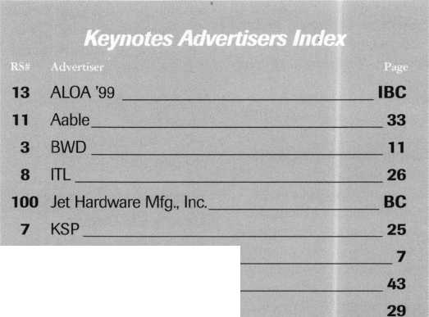

**bscription to** Locksmith Ledger International

**JTC3!** PleaseQ start Qextend i

3 YEARS (includes 36 issues, 3 FREE Ann

USA $90.00

* 2 YEARS (includes 24 issues, 2 FREE Annual Directory* issues)

USA $64.00Canada $91.00International (air) $179.00

* 1 YEAR (includes 12 issues, 1 FREE Annual Directory* issue)

Directory* issues)

International (surface) $119.00

USA $38.00Canada $52.00International (air) $95.00International (surface) $65.00

• Comprehensive guide to industry manufacturers, distributors, products and services.

**CARD INVALID UNLESS COMPLETE DATA IS GIVEN**You must indicate your locksmithing affiliation below

1. Are you a locksmith or an individual involved in locksmithing? □ YES □ NO
2. My position is: □Owner/Pres. 03 Employee 06 Student 09 Other
3. Business classification (check one only): A □Locksmith Shop B □Hardware

C □Wholesaler/Distributor D □Manufacturer E □Security or Maintenance  
1 □Consultant 3 □Industrial 5 □Government  
2QCommercial 4□institutional 6L0Police  
G □Architect/Specifier Z □Other (specify)

1. Are you involved in purchasing or influencing the purchase of locksmith products?

**□ yes ^no**

**Send payment to: Locksmith Publishing Corp. * 850 Busse Highway * Park Ridge, IL 60068  
Phone: 847-692-5940 • Fax: 847-692-4604 • Website: [www.lpc.simon-net.com](http://www.lpc.simon-net.com)**

Reader Service #12

Name

Company

Address

CityStateZip PhoneFax

Payment: (US FUNDS ONLY) Money OrderCharge CardCheck #

Complete for Charge Orders Only: VISA Master Card

Account # Exp. Date

Signature

IM8

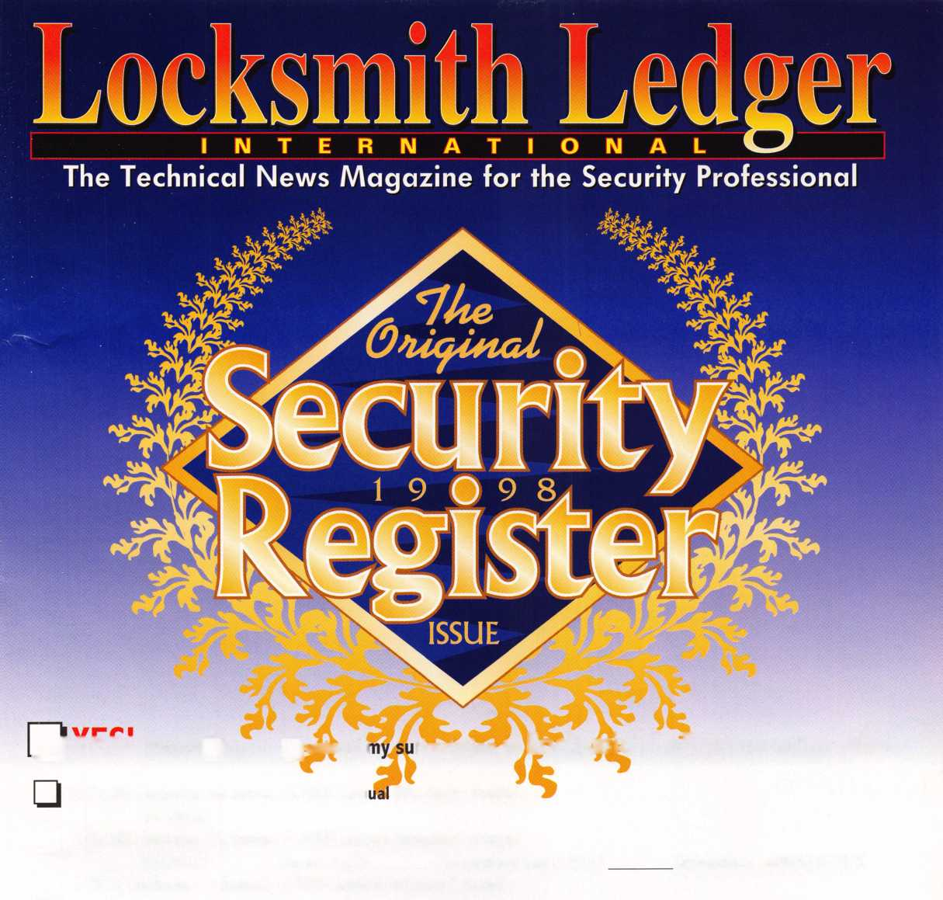

**Welcome to the**

**Cincinnati Zoo Caption Contest!**

Captured in living color (and in a carefully re-created habitat) is our friend the Sumatran Orangutan, who can be viewed in person at the Cincinnati Zoos Jungle Trails exhibit. Here’s how you and a friend can visit this guy for FREE while you’re at the ALOA ’99 Convention and Security Expo, July 25-32, in Cincinnati, Ohio:

Write a clever, funny photo caption that:

1. Can make at least one of the judges snicker;
2. Doesn’t take cheap shots at any individual (yes, that includes Clinton and your mother-in-law); and
3. Uses no smutty language (not that any of you would EVER talk like that).

How’s that for a challenge? Mail, fax or email your responses to:

**Keynotes Caption Contest**

3003 Live Oak Street Dallas, TX 75204 (214) 827-1810 fax [keynotes@anet-dfw.com](mailto:keynotes@anet-dfw.com)

P.S. We promise to print some of the funnier entries in a future issue and, if some of the runners-up are funny ENOUGH, we just might pass out some extra prizes;..

***Keynotes***



**IU LY** 25-3

DROP II

Plan now to be in the coolest place of all next summer.

Dive into a class, make a splash at a seminar and wave to your friends as you drift through the nation’s largest exposition of locksmith related manufacturers.

Refresh your spirit with a visit to Fountain Square, a ride on a riverboat, or by enjoying the breathtaking river view from Mt. Adams.

ALOA ’99 will be the coolest yet!

Call for details: 800.532.2562, or visit our website: [www.aloa.org](http://www.aloa.org).

Ji



Reader Service #13



**When it comet; to**

**key lor**

**Infiniti**

**eating a transponder issan Maxima or y don't have-much of**

**curre**

**a choice**

JET DA31-PHT 1999 Nissan Maxima 1999 Infiniti 130

**♦ Confirmed by independent trials.**

♦ ♦

The Jet etd-1

Transponder Kc

Duplication

made Easy.

This easy-to-use decoder quickly and accurately duplicates the most popular transponder keys, including: CADILLAC CATERA, SEVILLE anc future GM’s, MAZDA 626, HONDA / ACURA, and AUDI / VOLKSWAGEN / PORSCHE.

Included with your purchase are 30 programmable keys (retail value of keys over $1,500.00) along with a colorful window decal.

Available through your favorite JET distributor.

Reader Service HI 00

JET HARDWARE MANUFACTURING CORP

800 Hinsdale Street, Brooklyn NY 11207

